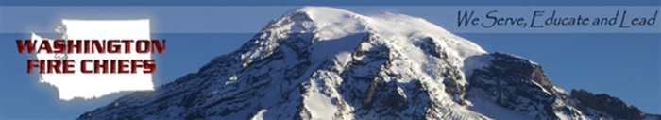

NO-MAN'S LAND LEGISLATION

Especially in rural parts of Washington State, many homes and properties are located outside of fire protection jurisdictions, meaning those properties are officially “unprotected” by fire service professionals. Although the owners of these lands do not pay for fire service, when a fire occurs on such lands, fire service agencies are often asked to respond. Because these fire service agencies are not officially responsible for fighting fires on those lands, however, confusion often ensues. A fire service agency that responds does so at the cost and risk to the areas they are paid to protect, leaving taxpaying citizens vulnerable.

In order to best serve the citizens of Washington State, to ensure the best fire protection possible to all lands, and to create an incentive for fire service agencies to fight fires on unprotected lands, the Washington Fire Chiefs and the Washington Fire Commissioners are proposing legislation that will:

- Reduce the cost of state fire mobilization efforts and general fund expenditures by creating a better system for local fire service agencies to serve unprotected lands

- Encourage landowners to form or annex into existing fire protection service jurisdictions

- Encourage landowners to contract with nearby fire protection service agencies if formation or annexation is impractical

- Make clear that a fire protection service agency may respond to fires on unprotected lands when:
  - Specifically requested by the owner,
  - Doing so would reasonably be believed to prevent the spread of fire unto protected lands, and/or
  - Doing so would reasonably be believed to prevent the loss of life or property

- Allow for reasonable cost recovery by the fire protection service agency that is leaving its taxpaying citizens unprotected to fight the fire

- Provide limited civil immunity for firefighters who provide service to unprotected lands

- Add information as to whether a property is in a fire protection service jurisdiction to the real estate seller disclosure form

With passage of this important legislation, the citizens of Washington State will be provided with the most comprehensive fire service to date, and fire protection service agencies will have incentive to battle fires on unprotected lands without confusion or worry.

For further information, please contact:
J. Dylan Doty, WFC Lobbyist Gordon Walgren, WFC Lobbyist
206-790-6492 360-790-5017
dylandoty@yahoo.com walgconsult@telebyte.com

Wayne Senter, WFC Legislative Chair Mike Brown, WFC Executive Director
360-871-2411 360-352-0161
wsenter@skfr.org mike@washingtonfirechiefs.org

