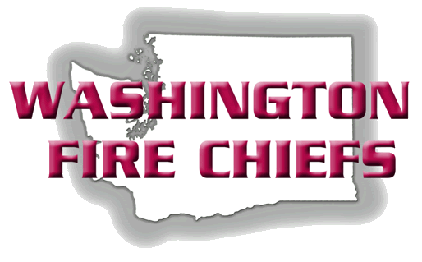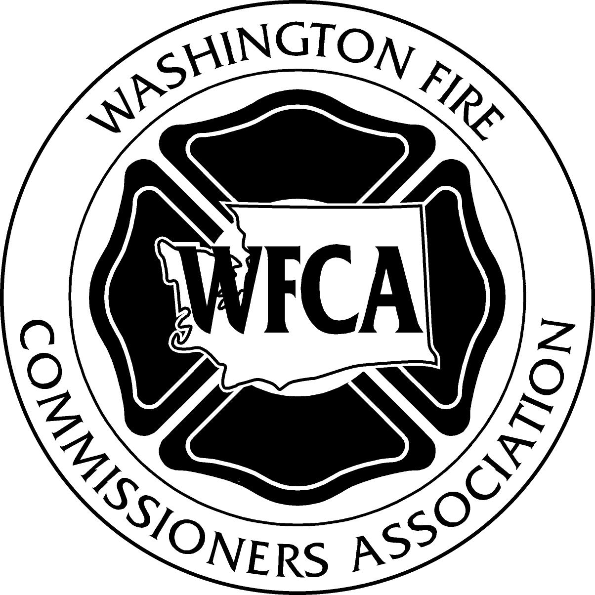

Anne Soiza
Assistant Director,
Department of Labor and Industry

Kimberly Johnson
Administrative Regulations Analyst

Department of Labor and Industry
P.O. Box 44620,
Olympia WA 98504-4620

Dear Ms. Soiza and Ms Johnson

RE: WAC 296-305 Recommended Amendments

Dear Ms. Soiza and Ms Johnson,

The Washington Fire Commissioners and Washington Fire Chiefs would like to submit for the record its recommended improvements to the proposed revisions of WAC 296-305-305. We respectfully request the following sections be amended as follows:

296-305-01002 Effective date
WFCA & WFC request an implementation date of July 1, 2012.
Explanation: This date will to allow development of budgets, accommodate staffing requirements for all standards, procedures, and training programs required for compliance. In addition this allows time for our association to develop sample compliance documents for our members and presentation to elected officials to address budgeting requirements.

296-305-01005 Definitions
Delete “Life Safety Harness Class 1”
Explanation: Unused in document.

Amend “Exclusion zone”. Delete the word “control”.
Explanation: Confusion between Public Exclusion and Personnel Exclusion.

Amend “Initial Fire Suppression Training” to read “The training of firefighters in recognizing sources and locations of potential fires and methods of fire suppressions as defined by the local jurisdiction.”
Explanation: Clarifies authority having jurisdiction may have specific operating procedures.

Include in definition of fire department, “An organization, or consortium of organizations, providing…)
Explanation: Clarifies that an organization is a department or, consortium of organizations, providing typical fire department services.

296-305-01503 Accident investigation
Amend “Accident” to “Incident”
Delete "trained"
Explanation: Recognizes definition.

296-305-01509 Management’s responsibility
Substitute "officer" for "administrator"
(7)(B) Include "…or other licensed health care provider qualified by training or experience as determined by the fire department to evaluate firefighters”.
Explanation: Retains consistent title of Health and Safety Officer and allows the fire department some administrative discretion.
296-305-02012 Body armor
Remove note “Employees may exceed the minimum requirements for body armor if they choose”.
Explanation: Conflicts with the management’s responsibility to provide all protection clothing items.

296-305-02501 Emergency medical protection
Remove Note 1 in (15)(b)(ii) “Emergency response personnel should be…”
Explanation: There are no requirements currently by the CDC for ongoing TB testing, and there are multiple methods for testing now available.

296-305-03002 Hazardous materials.
Section 4 -Include text “…designed by the manufacturer for respiratory protection for that type…”
Explanation: Clarifies area of protection.

Section 5 - Add Note “Refer to the NFPA 1991, 1992 from 2000 edition.”
Explanation: Section 5 is in conflict with the NFPA standard referenced.

296-305-04001 Respiratory equipment protection
(9)(A) Add definition for “Gross/field decontamination”.
Explanation: As without definition is open to broad interpretation, methods of accomplishing

296-305-04501 Automotive fire apparatus design and construction
(1) Change to read "..the 2003 Edition of NFPA 1901 Standard for Automotive Fire Apparatus and NFPA 1906 Standard for Wildland Fire Apparatus, 2006 Edition.
Explanation: The referenced edition of the NFPA 1901 Standard no longer includes Wildand apparatus.
(11) Change convert to a note and change “must comply…” to “should refer to…”
Explanation Users must already comply with the reference RCW redundant requirements

296-305-04505 Automotive apparatus operational rules.
(8) Change to read “additional reference: Washington Fire Chiefs Emergency Vehicle Incident Prevention (EVIP) Program or other Washington state accredited program.”
Explanation: Clarification of titles.
Add to “additional resources” NFPA 1911.

296-305-04507 Fire apparatus maintenance and repair
(3) Correct typographical error to read ASE rather than ASC
(11) Add note "Refer to NFPA 1911 Standard for the Inspection, Maintenance, Test and Retirement of in-service fire apparatus. 2009 Edition”.
Explanation: Corrects typo. Clarifies source of note

296-305-04510 Aerial apparatus
(4)(E) Add Note. “Aerial devices may be utilized for ventilation in accordance with manufacturer’s recommendations.”
(4)(g) Delete “class I safety belt”. To read “…they shall be secured by at least a ladder belt”.

(7)(f) Replace with “Sand or similar product…”
Explanation: Allows user to follow manufacturer’s recommendations

296-305-05000 Incident management
(8) Add Note. "The Incident Commander may declare the IDLH and Hot Zone for each incident. Safety Officers, Division and Group Supervisors may operate in Hot Zones independently”.
Explanation: Clarifies that Safety Officers, Division/Group Supervisors can operate independently within a Hot Zone; and must also remain in constant communication with incident command.

(11) Substitute “…all efforts shall be made…” to “…all reasonable efforts…”.

(12) Replace with this text “Employees working on, over or along water where the damage of drowning exists shall be provided and shall use approved personal floatation devices. Employees are not considered to be in danger of drowning when the water depth is known to be less than chest deep on the exposed individual”. See 05113 5 (J) (ii)
Explanation: Clarifies description of "shallow water" in 05113(5) J (ii)

296-305-05002 Fire suppression
(6)(c) Substitute “Standby firefighters may be permitted to perform other duties outside the hot zone…” "See appendix D”
Explanation: This requirement will decrease incident capability and safety. Limiting duties directed by the incident commander to one standby firefighter outside the hot zone will unnecessarily expose the single member to injury or prevent the incident commander from implementing measures that cannot be safely accomplished by a single member.

(13) (16) Compliance with WAC 296-841 conflicts with 296-305-01003 (6).

(16) Change to, “Members conducting post fire investigations must to comply with 05002 (12) to (15)”.
Explanation: This requirement is unmanageable and establishes a staffing requirement and establishes a cost and requires technology not available to meet these requirements.

296-305-05004 Occupational exposure to heat and cold stress
(1) Amend to say “The incident commander at emergency incidents and/or supervisors at emergency training exercises shall provide for members who become dehydrated or show signs of heat related illness with drinking water and relief from climatic conditions. Employers, as a minimum, shall refer to NFPA 1584 Recommended Practice on the Rehabilitation of Members Operation at Incident Scene Operations and Training Exercises 2008 Edition.”

(k) Move Table I into appendices as a reference.

(2) through (17) Delete and reference in appendices.
(4) “Employers who provide fire protection services must comply with WAC 296-305 and, unless otherwise provided follow WAC 206-62-09510”
Explanation: This requirement is unmanageable at all fire scenes during rehabilitation process, although WFCA and Washington Fire Chiefs were assured in L&I response to public hearing that WAC 296-62-095 would have coordinating language which they have provided. (see our comment (1) above)

296-305-05013 Aircraft rescue and firefighting
(1) Change “…shall meet…” to “…shall review…”.
Explanation: The requirement is too broad for fire departments without an expansive definition of "aircraft"

296-305-05103 Technical rescue training
Keep only first two sentences of (1). Convert the remaining portion of (1) to a note, in reference to appropriate standards.
Explanation: Unworkable and requires resource staffing that is not consistently available at all incidents.

296-305-05107 Technical rescue incident response planning
(1) Amend to say “Fire Organizations who choose to operate at the operations level or above shall have written policies and procedures to cover the level of response capability in their area.”
(2) Clarify: does mutual aid and automatic aid comply?
(3) Change “Department” to “Organization”
Explanation: These requirements are unworkable for Fire Protection Districts with multiple mutual aid agreements or respond as regional resources.

296-305-05111 Technical rescue safety
(3) Amend to read, “The incident commander shall assign an incident safety officer… with requisite knowledge…”
Explanation: The incident commander can only make assignments from staff available and select a resource with knowledge appropriate as the scene develops.

296-305-05113 Technical rescue operational specialties
Convert all NFPA references to a note, and replace with “…should refer to the appropriate nationally recognized standards and guidelines for development of operational and technical guidelines.” This recommendation would be made throughout this section.
Delete sections (2)(b) through (d)(vi) due to duplication with section 296-305-02019 and inconsistencies between these two sections.
Explanation: WFC & WFCA reminds L&I that the stakeholder committee did not recommend specific NFPA requirements in this document.

(5)(J)(ii) Replace "wear" with "use”.
Explanation: Clarifies that rescue members may be directed that work ensemble and activities may not always allow them to wear a PFD.
(5)(J)(ii) Add to exception “... employees working below deck, in enclosed cabins or in shallow water..” See Section 05000 (12)

296-305-05502 Training and member development
(6)(a) Amend to read, "Members who engage in interior structural firefighting in IDLH conditions shall be provided live fire training or on scene experience appropriate to their assigned duties and functions they are expected to perform at least every five years. Firefighters who do not receive this training or experience will not be eligible to return to an interior structural firefighting assignment until this requirement is met. Firefighters who meet the following criteria meet the training requirement. Firefighters who arrive on a fire scene with a full alarm assignment, with an incident command structure established and a Post Incident Analysis is conducted will qualify personnel as compliant with this requirement.”
Explanation: The five year limit cannot be accomplished if limited to attendance at fixed training sites.

(7) (c) Move Table X to the appendix. Include “refer to table X appendices…”
Explanation: Appendix reference needed to facilitate standardization between otherwise certified driver training programs

296-305-06008 Electrical
(2)(a) Delete “20 amp rated at 120 VAC”
Explanation: On-scene service equipment will require a portable cord reel provided with a 15 amp plug connection. The 20 amp requirement will require an adapter which comprises the otherwise simple connection of like plugs and sockets.

296-305-06509
Missing. This section is missing. Where did it go?

296-305-065603 General requirements
(16)(e) Restore language now provided in WAC 296-305-06509 Apparatus areas.
Explanation: Needed for clarity as 305 is primary reference

296-305-07004 Heat-related illness prevention for wildfire and wildland firefighters
Delete (1) and (5).
Amend (3) to say “rest, rehabilitation and hydration of all members…”
Explanation: Hydration is consistent with basic heat-related illness prevention and is always associated with rest and rehabilitation.

296-305-07016 Falling equipment in forest lands
Move this section to appendices. Replace with text, “Firefighters who must fall trees in forest land, shall have obtained appropriate NWCG training qualifications”.
Explanation: NWCG is the sole recognized Wildfire National Certification Standard and is required in State Mobilization.

296-305-08000 Appendix E
Restore Appendix E. Standard apparatus operation communications.
Explanation: Reference should encourage standardization between otherwise certified driver training programs.

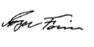

Mike Brown | Roger Ferris
Executive Director | Executive Secretary
Washington Fire Chiefs | Washington Fire Commissioners Association

