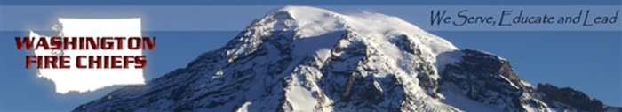

Quick update on the happenings in Olympia Tuesday March 6, 2012:

We have our first bill signing of the year tomorrow at 1:30 in the Governor's office. HB 2213, the bill altering the definition of "improved property" for our no-man's land bill, will be signed into law.

HB 1552, the garnishment bill that was amended to protect public-employee pensions, passed the Senate on Friday and the House concurred in the amendments, meaning it is on its way to the Governor.

HB 1820, implementing the blue alert system for law enforcement officers, was amended to apply to all firefighters as well. It passed the House and Senate and is on its way to the Governor. This will allow an amber-alert like system when an officer is injured or killed at the hands of another.

HB 2280, the yellow-dot program, failed to move out of Rules prior to Friday's 5:00 pm cutoff. It is likely dead this session, though it could be brought back if there is enough urge to move it.

HB 1627, the boundary review board bill, passed the Senate after being amended to remove House amendments that put some parameters around what BRBs could do. The House concurred with the Senate version, but we have commitments from the interested parties to rework the issue next year to improve the legislation.

SB 5766, the bill to expand fire district commissioners from 5 to 7 in certain circumstances, passed the House and is awaiting concurrence in the Senate. This is a bill the Commissioners really wanted.

HB 2440, the bill authorizing DNR to provide wildfire protection on public lands managed by state agencies, passed unanimously and has been delivered to the Governor.

SB 6120, the children's safe products act, failed to pass the House prior to Friday's cutoff, and has been returned to Rules. It is unlikely to move this year.

SB 5365, the bill authorizing the buyback of volunteer pension benefits that was strongly supported by Rex and others, passed and has been delivered to the Governor.

HB 2565, the roll-your-own cigarette bill, failed to pass the House at all; however, it has been moved to the House floor and may come up for a vote after all.

SB 6470, authorizing fire benefit charges by cities (primarily a Kirkland bill), passed and has been delivered to the Governor.

The budget is still in a major state of flux following Friday's actions by Senate Republicans. The belief that we'll end on time has started to wane. We shall see what happens.

J. Dylan Doty, Esq.
Jensen Walgren Doty Governmental Consulting
Cell: 206-790-6492
E-mail: dylandoty@yahoo.com
www.JensenWalgrenDoty.com

