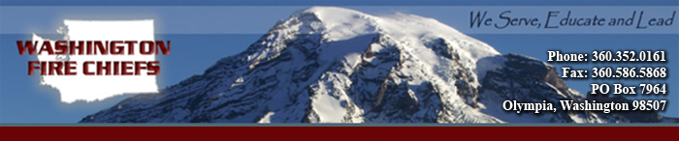

Washington Fire Chiefs

2013 Legislative Issues

Top 5 Issues

- All Risk Mobilization
- Fire Training Academy Burn Tower Funding
- Oppose Ambulance Billing Direct to Patient
- Raise EMS Levy Cap to $.75
- 2013 Wildland Prevention Act – Ready, Set, Go!

Important Issues

- JATC Funding
- Simple Majority for Benefit Service Charge
- Volunteer Firefighter Incentives
- Stable Funding for Pensions
- Residential Fire Sprinklers
- Public Records Requests Controls
- Apparatus Alternative fuels & Emissions
- Municipality to Form District
- CBRNE (send letter of importance)
- Boundary Review Board Limitations
- Wildland Urban Interface (WUI) Legislation
- Fire Service Messages on DOT E-Signs (JOPS)
- Proration Protections
- Public Safety Theft Penalties
- Simple Majority for M & O Levies

The issues were established by members in May 2012.
This list finalized by the legislative committee in June 2012
Additional issues will be identified and prioritized throughout the legislative process

