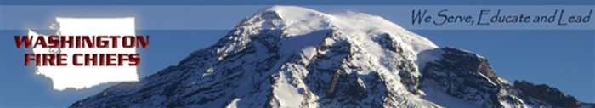

HB 1127 – The 2013 Wildland Fire Prevention Act

Background & Identified Problem
Wildfire occurrence, fire intensity and values at risk have continued to increase across the state in recent years. Three of the primary causal factors behind these increases are population growth, changes in land use, and weather patterns and drought. The 2012 wildfire season was one of the worst in history and caused untold millions of dollars’ worth of fire-related damages, with $17 million alone for state fire mobilization. Costs associated with ongoing fire resource deployment, state fire mobilization, as well as lingering air quality issues and freight delay due to road closures, have added up to one of the costliest fire seasons on record.

Purpose and Scope of Legislation
HB 1127 would task the State Fire Marshal with adopting the nationally-recognized fire mitigation program, “Ready Set Go.” This plan, which provides coordination and implementation assistance for local jurisdictions, establishes operational concepts and identifies responsibilities and tasks required to carry out a comprehensive wildfire management program.

The program uses a three-tiered system involving 1) communities and citizens, 2) local fire departments and local response resources responding to wildfires across the state, and 3) state wildfire mobilization to assist local and state resources. The bill would require development of individualized community-wide protection plans that include public education such as Firewise; partnership building between the state Fire Marshal’s Office, local fire jurisdictions, and local homeowners; and personal wildfire action plans for individuals living in the areas most impacted by wildfires.

Funding & Cost Savings
The bill would allow for 5% of the unallocated portion of the fire insurance premium tax, or approximately $700,000, to be used for necessary pre-fire mitigation planning. In 2012 alone, the state allocated over $17 million to fight wildfires, which comes from the state’s general fund budget. By spending just a fraction of that amount on pre-fire planning, the state could save millions in future allocations.

For further information, please contact:
J. Dylan Doty, WFC Lobbyist Gordon Walgren, WFC Lobbyist Mike Brown, WFC Executive Director
206-790-6492 360-790-5017 360-352-0161
dylandoty@yahoo.com walgconsult@telebyte.com mike@washingtonfirechiefs.org

The Washington Fire Chiefs Association urges your support of this important legislation.

