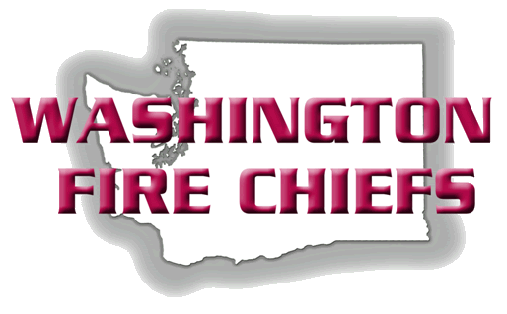
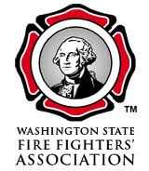
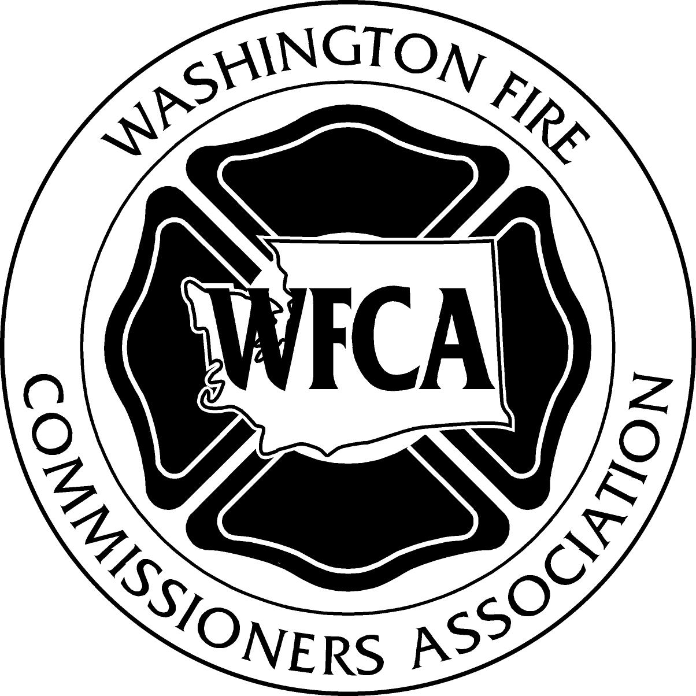
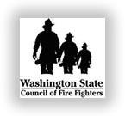

FUNDING FOR FIRE DISTRICTS AND REGIONAL FIRE AUTHORITIES

Fire Districts and Regional Fire Authorities (RFAs) are organized under Title 52 RCW.

The primary funding mechanisms for both Fire Districts and RFAs are:

- Regular Property Tax Levy – Property Taxes collected up to a maximum of $1.50 per $1,000 of assessed valuation.
  - Subject to the Constitutional 1% annual limitation
  - Limited to $1.00 per $1,000 of assessed value if benefit charge imposed

- Excess Levies – Property Taxes collected in excess of normal statutes, approved by a 60% favorable vote, and a 40% voter turnout requirement. Renewals also require a 60% favorable vote and a 40% turnout requirement.
  - Must be used for specific purposes only, limited to 2 or 4 years
  - Example would be a Maintenance & Operations (M&O) Levy

- Emergency Medical Service (EMS) Levies – Allows for Property Taxes up to $.50 per $1,000 of assessed valuation. Initially approved by a 60% favorable vote and a 40% turnout requirement for a period of 6 years, 10 years, or permanently. As of 2012, renewals are achieved through a simple majority vote, 50% plus one.
  - Subject to the same 1% limitation annually as all other property taxes
  - Last raised to $.50 in 1979

- Benefit Charges – A special fee imposed on personal property and improvements to real property in an amount not to exceed 60% of the operating budget of the fire district or RFA. Good for a six year period after achieving a 60% favorable vote. Renewals also require a 60% favorable vote.
  - If imposed, reduces property tax ceiling from $1.50 to $1.00 per $1,000

- Bond Issues – A property tax assessable for a fixed amount of years after receiving a majority vote from the governing board, or a 60% favorable vote of the local citizenry with a 40% turnout requirement, with the funds only allowed to be utilized for capital equipment, apparatus, or facilities.
  - Bonds must be repaid through taxation within a 20-year period.

**For more detailed information on each of these funding mechanisms, please see the attached appendix.

APPENDIX

REGULAR PROPERTY TAX LEVY, EXCESS LEVY, AND EMS LEVY:

What is the Regular Property Tax?
The regular property tax is a tax paid by homeowners and businesses, based on the assessed valuation (AV) of their property as determined by the County Assessor. Property tax levy rates are expressed in terms of dollars per $1,000 of assessed value. Property taxes are subject to constitutional and statutory limits described below. The property tax is the major source of tax revenues for most counties in the state, and a significant source of funding for other municipalities. Property taxes are often the primary source of funding for fire districts and RFAs. Fire Districts and RFAs can collect a maximum of $1.50 per $1,000 through a regular levy. However, if a benefit charge is imposed (RCW 52.18), then the collection of regular property taxes is limited to $1.00 per $1,000 of assessed valuation.

What types of property can be taxed?

Under Washington State law, real property and personal property can be assessed and taxed.

What determines the amount of tax?
The State and local governments will base their property tax levies on the amount of revenues they need for operations and capital purposes – i.e., their budget. However, beginning with the 106% levy lid in the 1970's and now with the 101% levy lid imposed by Initiative 747 (approved by voters in 2000, and codified into law in the 2008 Legislature), taxing districts frequently are not able to levy amounts sufficient to continue with existing service levels.

Are there different types of property tax levies?
There are two kinds of property tax levies:

- Regular Levies: Regular property taxes are levied annually without voter approval. These levies are subject to certain restrictions and legal limits (see below). A fire levy is a regular levy. A fire district or RFA can levy up to a maximum of $1.50 per $1,000 of assessed valuation, provided the organization has one paid employee. Without one paid employee, a fire district or RFA is limited to a maximum of $1.00 per $1,000 of assessed value (see RCW 52.16.130 for the first 50 cents of fire levy capacity, RCW 52.16.140 for the second 50 cents of fire levy capacity, and RCW 52.16.160 for the third 50 cents of fire levy capacity provided the district or RFA has at least one full-time paid employee).
- Excess Levies: Excess levies may be submitted to the voters in order to provide financing for specific purposes, such as general operating expenses or for capital purposes. The taxes collected are accounted for in separate funds. The state constitution requires that excess levies must be approved by a 60 percent favorable majority vote in an election where the voter turnout is equal to or greater than 40 % of those who voted in the most recent general election. Excess levies may be initiated for a 2 to a four year period (see RCW 84.52.052).

What is a taxing district?
A taxing district is an established area with taxing authority over that area. The most commonly known are the state, county, city, road, port, and school. These authorities are established by law.

There are also special districts, which are formed to meet specific needs. These special districts are formed by a petition of the people to meet the requirements of the area and they are overseen by the County Council or by a board of commissioners or trustees. Types of special districts are airport, cemetery, drainage, fire, flood control, hospital, library, metropolitan park, park and recreation, road, sewer, and water.

These special districts may be financed at least in part by property tax levies. Any regular levies they may impose are subject to the legal limitations established for property taxes. Some special purpose districts have only excess levy capacity (e.g. sewer). Fire, hospital and school districts use the excess levy more than other districts. (It should be noted that many library districts are multi-County, and due to this structure, the levy must pass in each County within the proposed library district.)

What are the legal limitations on property taxes?
- The 1% constitutional limit: The primary limitation on property taxes is established in the 17th amendment to the Washington State Constitution, approved in 1972. Article 7, Section 2 of the Constitution and RCW 84.52.050 limit the aggregate regular property tax levies of all taxing districts on an individual property to a maximum of one percent, or $10.00 per $1,000 of the market value of the property. In other words, the total property tax can be no more than one percent of true and fair value of the real or personal property. Excluded from this $10.00 limit are levies for ports, public utility districts and any excess levies.

- Statutory maximum rates for taxing districts: RCW 84.52.043 establishes maximum levy rates for the various taxing districts (the State, counties, cities and towns, fire districts, etc.). The statutory maximum rate for the County general levy is $1.80 and $2.25 for the County road levy. In addition, this statute establishes a maximum aggregate rate of $5.90 per $1,000 of assessed value for counties, cities, fire districts, library districts and certain other junior taxing districts. The state levy ($3.60) is not subject to the $5.90 limit, although it is subject to the constitutional $10 limit. However, if a tax district reaches its statutory rate limit, the tax rate can no longer increase and the taxing district would collect only the amount of tax revenue that would be produced by that statutory maximum levy rate.

- Pro-rationing: RCW 84.52.010 establishes the maximum levies that can be collected by senior (the State, Counties, and Cities) and junior taxing districts (fire districts and RFAs are junior taxing districts). Under certain circumstances, levy rates must be reduced due to the aforementioned $5.90 limitation. RCW 84.52.010 establishes the framework for levy reductions should the $5.90 be breached, although fire districts have 25 cents of protection above the $5.90 limitation per RCW 84.52.125 (this provision passed several years ago).

What is a levy lid lift?
A levy lid lift is a voter-approved measure that allows a taxing district to exceed the 1% property tax limit in a given year. A lid lift is only useful when a district has “capacity” within its statutory rate limit (i.e. if a fire district were operating at less than $1.50 per $1,000 of assessed value, a lid lift could be initiated to increase the levy up to the full $1.50). Levy lid lifts require a simple majority vote to be approved (50% plus one).

The 2007 Legislature approved new taxing authority for fire districts and RFAs to allow those jurisdictions to do multiple levy lid lifts for up to six years. However, the tax rate must be within the statutory levy limits. Further, it must be stated within the ballot itself as to whether the lid lift is “temporary”, returning to previous levels after the maximum six year period; or, if the lid lift remains at the higher levy capacity at the conclusion of the six year period, thus making it a “permanent” lid lift. The County may continue to use the old "rules" and just do a lid lift for one year, subject to the one percent lid process in future years. The Council can include in the title of the ballot measure a provision that the maximum amount of the levy in the final year of the lid lift will be the base for future levy increases. Otherwise, at the end of the lid lift period, the base will be reduced to what it would have been if there had been no lid lift. The election must be held in September (primary) or November (general.) Simple majority voter approval is required.

What happens if levy limits are exceeded?
The regular levy for each taxing district is reviewed by the Assessor for compliance with the 101% levy increase limit, the district’s statutory rate limit, and the $5.90 and 1% constitutional limits before the levy is made. If the $5.90 or 1% limits are exceeded, the levies must be reduced in order to comply with the limit. The reductions are prorated in accordance with a district hierarchy established in law.

The Statutory Levy Rate Limits, as established by RCW 84.52.010, 84.52.043 and other statutes, specify maximum regular levy rates for districts of various types. These regular levies are usually non-voted.

any exceptions?
There are three other “regular levies” that certain districts may impose that are outside the district’s statutory rate limits. They are:
- Conservation Futures which can be imposed by a County without a vote;
- Emergency Medical Services (EMS) which can be voted in for 6 years, 10 years, or on a permanent basis by a 60% vote in an EMS District (and a 40% turnout requirement); and
- Affordable Housing which can be voted in for 10 years by a simple majority vote in a city or county.

What is an emergency Medical Service Levy?
RCW 84.52.069 authorizes an EMS levy up to $.50 per $1,000 of assessed valuation to provide local emergency medical services. The EMS levy resides outside of the $5.90 authorization, so it is normally unaffected by pro-rationing issues identified in RCW 84.52.010. However, these levies can be pro-rationed if the constitutional limit of ten dollars per thousand of assessed valuation is exceeded. The first $.30 of this amount is held exclusively for EMS and is protected from pro-rationing.

The initial authorization of an EMS Levy must include the desired amount of the levy, and the statement of the levy period (6 years, 10 years, or permanent in nature). Passage requires a 60% favorable vote, with a 40% validation of voter turnout. Renewal levies (for the 6 year and 10 year levy) are now achieved through a simple majority election (50% plus one) based on the 2012 legislative session. EMS levies are subject to the same 1% limitation annually as are all other property taxes.

For entities that are part of a regional EMS system with a regional EMS levy, such as exists in King County, local jurisdictions could seek local voter approval for any additional levy capacity not included in the regional levy but not in the same year the regional levy is on the ballot (e.g. if King County were to run a 30 cent EMS levy in 2013, regional partners could also run up to a maximum 20 cent EMS levy to supplement their local services in 2014).

BENEFIT CHARGE (formerly referred to as Service Benefit Charges):

Chapter 52.18 RCW authorizes fire districts and RFAs to establish a benefit charge for a period of up to six years on personal property and improvements to real property. The total charge may provide up to 60% of the operating budget of the district or RFA. If the district or RFA elects to use a benefit charge, it may still levy a real property tax at a rate not to exceed one dollar ($1.00) per thousand of assessed valuation.

The benefit charge is not a property tax but rather a charge for services provided by the fire district or RFA to the properties in the jurisdiction for fire protection services. The charge is typically calculated on square footage augmented by property type (i.e. residential, commercial, multi-family, and mobile homes). The benefit charge is a charge for services provided to personal property and improvements to real property within the district or RFA, and cannot be charged against unimproved property (i.e. vacant land).

The benefit charge requires a 60% favorable vote for implementation, which must be renewed at least every six years (each requiring 60% favorable votes for renewal). RCW 52.18 also establishes the public hearing and benefit charge establishment process, which must be coordinated annually.

BOND ISSUES FOR CAPITAL NEEDS:

Fire districts and RFAs have the ability to issue general obligation (G.O.) bonds relative to their capital needs (e.g. fire equipment, fire apparatus, stations, etc.). Bonds may not be used for the general operations of the fire district or RFA (e.g. personnel costs).

Fire districts and RFAs may issue bonds upon approval of a majority of their governance board, either a Board of Fire Commissioners or a RFA Governance Board, equal to 3/8th of 1% of the total assessed valuation of the jurisdiction for the purpose of purchasing capital equipment, apparatus, modifying or adding facilities, purchasing real property, or other capital needs. These bonds need to be repaid from the fire district or RFAs general operating fund within 20 years of issuance per RCW 52.12.061.

Voter approved bonds may be issued with a favorable 60% vote of the citizens within the jurisdiction, and a 40% turnout requirement, allowing real and improved property to be taxed in order to pay off the bond debt over a period of time by the citizens within the district or RFA. These bonds may be issued in a higher amount than the aforementioned bonds issued by the jurisdiction without a public vote, but shall not incur district or RFA indebtedness higher than 3/4s of 1% of the total assessed value within the jurisdiction. These bonds must be repaid through tax collections within a 20 year period per RCW 52.16.080.

SUMMARY:

This white paper has attempted to identify the majority of funding mechanisms in use for fire districts and RFAs. With the recent recession and loss of assessed values on real and improved property, fire districts and RFAs are challenged more now than ever in that their revenue typically targets property values. With no ability to collect sales taxes, business and occupation taxes, utility taxes, or other municipal revenue streams, it is more important than ever for fire service leaders to work with their local legislators to ensure a clear understanding is achieved relative to the funding available for fire jurisdictions.

