Workers’ Compensation Premium Estimator for Preliminary 2018 Rates

The attached excel spreadsheet is a tool to help fire districts estimate their workers’ compensation premium costs in 2018. It includes the preliminary experience factor for each fire district. After entering estimated hours for the upcoming year, the spreadsheet will calculate total premiums, showing the employee and employer portion.

Please note that these rates are preliminary. The public is invited to comment on L&I's proposed rates at public hearings around the state in October. The final rate decision will be announced by early December. Complete information is online at www.Lni.wa.gov/Rates.

How do I use this tool to estimate my premiums for 2018?

Step 1:
Look-up your organization’s experience factor in the tab labeled “Prelim 2018 Exp Factors”

Step 2:
Enter you organization’s preliminary 2018 experience factor in the green cell in the top left-hand corner of the tab labeled “Premium Estimator”
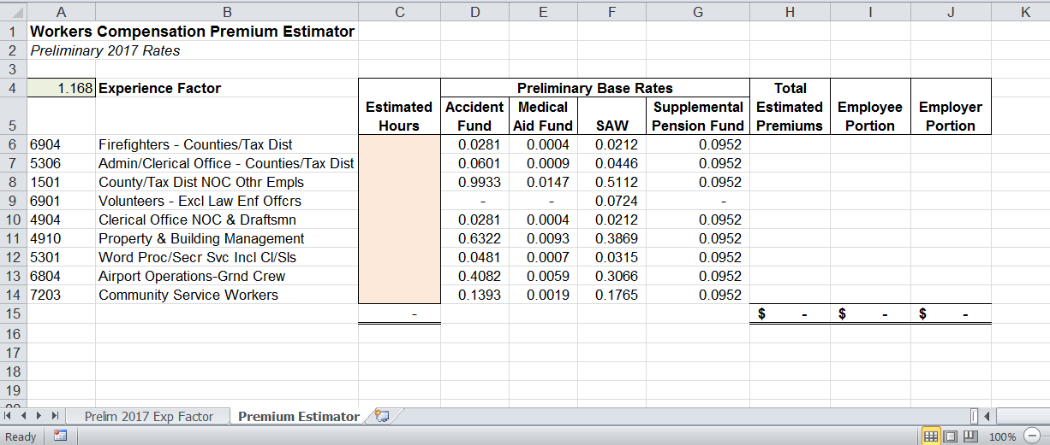
Step 3:
Enter the estimated hours for 2018 in the orange cells for each risk classification that your organization has. Note: most fire districts will only have employees in risk classifications 6904 (Firefighters) and 5306 (Admin/Clerical Office).
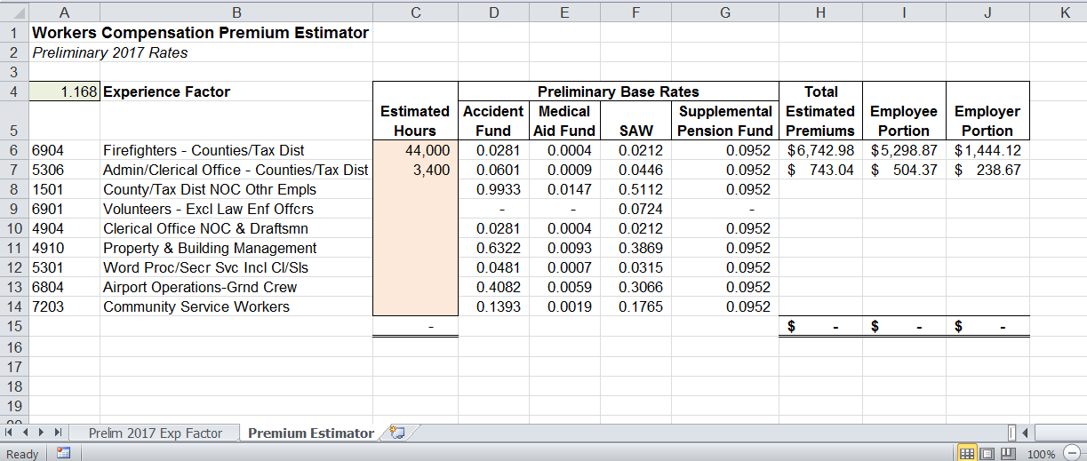

Frequently Asked Questions about Workers Compensation Premiums

How are premiums calculated for an individual employer?
For each risk class assigned to an employer their quarterly premium is calculated as:

Hours | x | ( | [ | Firm’s Experience Factor | x | ( | Accident base rate* + Medical Aid base rate* + Stay at Work base rate* | ) | ] | + | Supplemental Pension Fund  rate* | )
*The base rates are unique to the employer’s assigned risk classification

Note: the experience factor is not applied to the Supplemental Pension Fund Base Rate.

How often are the base rates and experience factors calculated?
The classification base rates and individual firm experience factors are updated annually, and the new rates and factors effective on January 1.

How are experience factors calculated?
L&I calculates the experience factor by comparing a firm’s workers’ compensation claim costs to the average costs of other firms with the same risk classification. If a firm is expected to have lower claims costs than the average employer it its class, then their experience factor will be less than 1.0.

Which years of losses are used to calculate the experience factor?
The experience period is the three fiscal years ending 18 months before the rating year. For example, the 2018 experience factors were based on claims costs between July 1, 2013 and June 30, 2016.

How are base rates for each risk classification calculated?
The base rates are calculated separately for the Accident Fund, Medical Aid Fund, and Stay at Work program in each risk classification. These base rates reflect the estimated cost of providing insurance for work in that risk classification.

The Supplemental Pension Fund hourly rate is the same for all classes rated per hour worked and is not related to the risk in the class. By statute the Supplemental Pension Fund is allowed to collect only enough premium to make the current COLA payments for new and past claims.

Which years of losses are used to calculate the base rates?
Base rates are calculated using claim costs and reported hours from the five fiscal years ending 18 months before the rating year. For example, the 2018 base rates were based on claim costs between July 1, 2011 and June 30, 2016

