COVID 19
PROCEDURE MANUAL
UPDATED 3-19-2020

*This is a guideline that is dynamic, fluid and changing on a daily basis and not designed to be all encompassing.

Version 19.1 / 03-19-2020 Note: Subject to change based on current recommendations

Response Checklist - COVID-19
All EMS Responses - Medium Precautions - Level II
- PPE – minimum for all providers:
  - Gloves & Goggles & N-95 on all EMS calls, including MVCs.
- Post response, if patient determined to be effectively no risk for COVID-19
- N-95 respirator may be stored in paper bag for later use (keep for no longer than 8 hours).
- Door Triage/room scan/6 ft of separation:
  - Does anyone have fever, cough, respiratory distress? YES- Level III PPE
  - Dispatch positive screen for PPE? YES-follow instructions 3 and 4 below:
- Treatment Precautions:
- If safe/feasible, consider having the patient brought to the entry point of the building.
- Minimize providers in the building required for patient care.
- Surgical mask for the patient, nasal cannula can be used under a surgical mask.
- A surgical mask can be placed over a non-rebreather mask.
- NO ORAL TEMPERATURES
- Transport Precautions:
  - Driver will remove eye protection/gloves. Minimize providers in the back of unit.
  - CDC guidance for ventilation during transport, see “Transporting Instructions.”
Assisted care, adult family home, nursing home, clinic, jail, other high-risk facility = Level III PPE
High Precautions - Level III
- Does anyone have a fever, or cough, or respiratory distress?
- Is the Patient or Facility suspected to have COVID-19?
- Had previous contact with a COVID-19 patient?
- Is patient from a high-risk facility (Assisted Care, AFH, Nursing home, clinic, jail)?
- May require aerosol-generating procedures?
If Yes to any question = High Precaution Level III PPE If No to all questions = Level II PPE
1. PPE- gloves, N-95, goggles or face shield, and gown. Surgical mask on patient.
- Follow all Instructions in Level II
- Contact the MSO for support as needed.
- Contact destination hospital and advise you have an isolation patient.
Precautions for Aerosol Generating Procedures
If patient condition REQUIRES use of invasive airway interventions:
- Level III PPE required during all aerosol generating procedures:
  - BVM, Suctioning, CPAP, iGel, Intubation, Nebulized meds, NRB (if no surgical mask).
  - Nebulized meds used as a last resort-consider other appropriate treatments first.
- BVMs should be equipped with HEPA filters.
- Use Supraglottic airway (SGA) instead of intubation for suspected/known COVID-19 patients.
  - Intubation allowed if SGA will not oxygenate and ventilate.
- DO NOT USE VENTILATORS
- Maximize area ventilation during these procedures-open doors, use exhaust fans.
- Contact Medical Control as needed for guidance.

Version 19.1 / 03-19-2020 Note: Subject to change based on current recommendations

Transporting Instructions
- Crews will not transport family members of any patient except parents/guardians, POA, special needs

NOTE: Per CDC, Hospitals not accepting any visitors. Only parents/guardians, POA, special needs patients.
There may be exceptions for end of life situations.

- Isolate the ambulance driver from the patient compartment.

- During transport, vehicle ventilation in both compartments should be on non-recirculated mode to maximize air changes that reduce potentially infectious particles in the vehicle. If the vehicle has a rear exhaust fan, use it to draw air away from the cab, toward the patient-care area, and out the back end of the vehicle.

- Open the outside air vents in the driver area and turn on the ventilation fans to the highest setting.

Decontamination Checklist
Daily - Deep cleaning of stations and apparatus will be conducted at the start of every shift.
ALL PRIMARY DECON TO BE DONE BEFORE ENTERING STATION. DO NOT CONTAMINATE STATION.
PPE Gowns = single use Eye Protection and Goggles = decontaminate and reuse. Level II – Properly dispose of PPE. Wash hands. Deep clean apparatus.
Level III - Transport units will perform decon at hospital:
Properly dispose of PPE. Wash hands. Deep clean apparatus. Disinfect goggles then wash with soap/water. Launder uniforms as appropriate per agency infection control guidelines
If any aerosol generating procedures were performed on a COVID-19 SUSPICIOUS PATIENT (symptoms or possible contact with COVID pt) or any time providers feel that higher level decon is warranted:
- After patient transfer, properly dispose of PPE and wash hands.
- Deep clean apparatus wearing PPE (see guidelines below). Decon boots with spray CaviCide1.
- Outside rig or in hospital decon room, doff and bag uniforms, don Tyvek suit.
- Place bagged uniforms in exterior compartment.
- Return to station. Launder uniforms wearing PPE. Note: Crew members involved in aerosol
- Shower and don fresh uniforms. generating procedures who do not transport: See decon guidance on page 3
Cleaning EMS Transport Unit after Transporting a Patient with Suspected/Confirmed COVID-19
- Allow for maximum ventilation in patient compartment by keeping all doors open while delivering patient.

- PPE for rig decon: googles, mask and gloves minimum. Gown if splashes or sprays anticipated.

- Routine cleaning and disinfection procedures (e.g. using cleaners and water to pre-clean surfaces prior to applying disinfectant) are appropriate for SARS-CoV-2 (COVID-19). Pre-cleaning removes gross contaminants prior to disinfection.

- Follow directions on CaviCide1 bottle for thorough disinfection.

- Products with EPA-approved emerging viral pathogens claims are recommended for use against SARS-CoV-2. Refer to List N on EPA website. CaviCide1 has demonstrated effectiveness against viruses similar to SARS-CoV-2 on hard non- porous surfaces. Therefore, this product can be used against SARS-CoV-2 when used in accordance with the directions on hard, non-porous surfaces.” Follow directions on the CaviCide1 Bottle.

- Clean and disinfect all surfaces that patient may have contacted and all surfaces that may have been contaminated by aerosol generation.

- Clean and disinfect all reusable patient-care equipment before use on another patient. Primarily use CaviCide1 spray, and allow a dwell time of 1-2 minutes. CaviWipes 1 are for items that are difficult to clean with a liquid, e.g., EKG leads.

Version 19.1 / 03-19-2020 Note: Subject to change based on current recommendations

PPE Precautions – Levels I, II, III

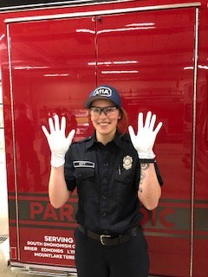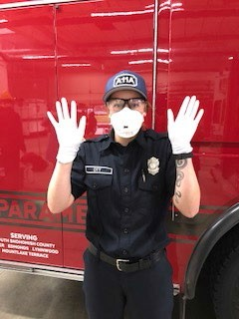
GOGGLES

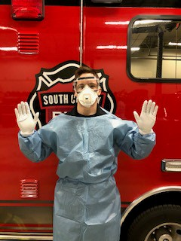Level I / Standard Level II / Medium Level III / High

-Gloves
-N-95
-Goggles
-Gloves
-N-95
-Goggles/Face Shield
-Gown

Donning PPE Sequence: MEGG To Doff PPE, just reverse the donning sequence: GGEM

- Mask 1. Gloves
- Eyes 2. Gown- Wash Hands
- Gown 3. Eyes
4. Gloves 4. Mask- Wash Hands
Decon guidance for non-transport crews when aerosol generating procedures were performed on COVID-19 SUSPICIOUS PATIENT
AT SCENE:
- Doff and bag all PPE.
- Decon boots.
- Doff and bag uniforms.
- Don Tyvek suit.
- Bagged uniforms placed in exterior compartment.
- Return to station. If unable to decon at scene:
- Launder contaminated uniforms wearing PPE. Do steps 1-4 on ramp-NOT INSIDE THE BAY
- Shower and don fresh uniform. Decon inside of rig wearing PPE per instructions on page 2.

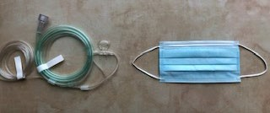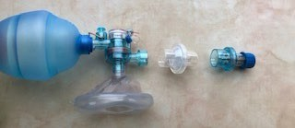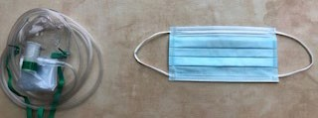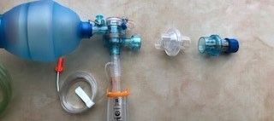
Version 19.1 / 03-19-2020 Note: Subject to change based on current recommendations

OXYGEN or ADVANCED AIRWAY MANAGEMENT
 | Nasal Cannula  - Place nasal cannula  - Place surgical mask over the face  - Titrate oxygen flow rate from 2-6 LPM |  | Non-Rebreather  - Place non-rebreather mask  - Place surgical mask over the face on top of NRB mask  - Titrate oxygen flow rate from 6-15 LPM
 | BVM  - Place HEPA filter on exhalation port  - Ensure and maintain mask seal  - Titrate oxygen flow rate to patient need |  | I-gel  - Place HEPA filter on exhalation port  - Place ETCO2  - Ensure I-gel is seated appropriately

EMS - COVID-19 HOSPITAL NOTIFICATION CHECKLIST
 | YES to both questions in this | RED | box = Advise Hospital of a HIGH probability isolation patient:

Symptoms: Has the patient had any off the following symptoms of acute respiratory infection?
  - Fever (or subjective fever)
  - New cough
  - New shortness of breath (without alternative diagnosis)
  - New onset myalgias (soreness/achiness in muscles)

- Exposure: Has the patient had any of the following in the last 14 days before symptom onset?

Close contact with, or part of, an COVID-19 illness cluster in a facility or group
  - Close contact with a suspected or lab-confirmed COVID-19 case
  - Healthcare worker or in a high-risk occupation (e.g. EMS, firefighter, public safety)

- IF you do not have a YES answer to BOTH box proceed to next checklist
YES to any questions in this YELLOW box = Advise Hospital of a MEDIUM probability isolation patient:

Cough
- Runny nose
- Sore throat
IF NO to all questions in this YELLOW box proceed to next box

IF NO to ALL RED and YELLOW box questions = Advise Hospital of a LOW probability isolation patient
5

BC Sick Employee Algorithm
When any employee reports sick on or off duty, ask following YES or NO
questions:
- Do you have a Fever?
- Do you have a Cough?
- Are you Short of Breath?
- Do you have Fatigue or Body Aches?
- Have you had recent contact with a known COVID POSITIVE person without full PPE?:
  - A patient?
  - Family member, friend, co-worker and/or other?

If YES to ANY of the above-roster off “Sick-Pending” for next 72 hours

Direct employee to call:

MSO Keene at 425.754.1740 or MSO Grantier at 425.309.2766

GIVE EMPLOYEE BOTH NUMBERS
They HAVE to talk to one of the MSOs.

If NO to ALL of the above questions:

- Roster as “Sick-Employee”
- Email hr@southsnofire.org with employee name and date of sick call.

6

BC Sick Employee Workflow

On Duty
Off Duty

Captain
Contact BC
Complete BC Sick Employee Algorithm
BC

BC - Ensure on-duty illness (OSHA
301) and ESO PCR
completed on employee
Yes?
COVID-19 Symptoms
No?
Surgical Mask on employee and separate from crew (if on-duty) and send home.
Email HR@southsnofire.org BC's roster as sick employee
MSO Grantier
425.309.2766 and/or MSO Keene 425.754.1740
BC
MSO/ HR
SCF MSO Complete Illness Report Form
SCF HR Complete Illness Report
Form

Testing process

14 Day Symptom Monitoring Tracker for Employee Exposure/Potential Exposure

Day # (from last contact) | 1 |  |  |  |  | 2 |  |  |  | 3 |  |  |  | 4 |  |  | 5 |  |  |  | 6 |  |  | 7
Date
AM or PM | AM |  |  | PM |  | AM |  | PM |  | AM |  | PM |  | AM | PM |  | AM |  | PM |  | AM | PM |  | AM |  | PM
Temperature
Felt feverish | Y |  | N | Y | N | Y | N | Y | N | Y | N | Y | N | Y N | Y | N | Y | N | Y | N | Y N | Y | N | Y | N | Y | N
Cough | Y |  | N | Y | N | Y | N | Y | N | Y | N | Y | N | Y N | Y | N | Y | N | Y | N | Y N | Y | N | Y | N | Y | N
Sore Throat | Y |  | N | Y | N | Y | N | Y | N | Y | N | Y | N | Y N | Y | N | Y | N | Y | N | Y N | Y | N | Y | N | Y | N
Difficulty breathing/shortness of breath | Y |  | N | Y | N | Y | N | Y | N | Y | N | Y | N | Y N | Y | N | Y | N | Y | N | Y N | Y | N | Y | N | Y | N
Muscle aches/headache | Y |  | N | Y | N | Y | N | Y | N | Y | N | Y | N | Y N | Y | N | Y | N | Y | N | Y N | Y | N | Y | N | Y | N
Abdominal discomfort | Y |  | N | Y | N | Y | N | Y | N | Y | N | Y | N | Y N | Y | N | Y | N | Y | N | Y N | Y | N | Y | N | Y | N
Vomiting | Y |  | N | Y | N | Y | N | Y | N | Y | N | Y | N | Y N | Y | N | Y | N | Y | N | Y N | Y | N | Y | N | Y | N
Diarrhea | Y |  | N | Y | N | Y | N | Y | N | Y | N | Y | N | Y N | Y | N | Y | N | Y | N | Y N | Y | N | Y | N | Y | N
Day # (from last contact) | 8 |  |  |  |  | 9 |  |  |  | 10 |  |  |  | 11 |  |  | 12 |  |  |  | 13 |  |  | 14
Date
AM or PM | AM |  |  | PM |  | AM |  | PM |  | AM |  | PM |  | AM | PM |  | AM |  | PM |  | AM | PM |  | AM |  | PM
Temperature
Felt feverish | Y |  | N | Y | N | Y | N | Y | N | Y | N | Y | N | Y N | Y | N | Y | N | Y | N | Y N | Y | N | Y | N | Y | N
Cough | Y |  | N | Y | N | Y | N | Y | N | Y | N | Y | N | Y N | Y | N | Y | N | Y | N | Y N | Y | N | Y | N | Y | N
Sore Throat | Y |  | N | Y | N | Y | N | Y | N | Y | N | Y | N | Y N | Y | N | Y | N | Y | N | Y N | Y | N | Y | N | Y | N
Difficulty breathing/shortness of breath | Y |  | N | Y | N | Y | N | Y | N | Y | N | Y | N | Y N | Y | N | Y | N | Y | N | Y N | Y | N | Y | N | Y | N
Muscle aches/headache | Y |  | N | Y | N | Y | N | Y | N | Y | N | Y | N | Y N | Y | N | Y | N | Y | N | Y N | Y | N | Y | N | Y | N
Abdominal discomfort | Y |  | N | Y | N | Y | N | Y | N | Y | N | Y | N | Y N | Y | N | Y | N | Y | N | Y N | Y | N | Y | N | Y | N
Vomiting | Y |  | N | Y | N | Y | N | Y | N | Y | N | Y | N | Y N | Y | N | Y | N | Y | N | Y N | Y | N | Y | N | Y | N
Diarrhea | Y |  | N | Y | N | Y | N | Y | N | Y | N | Y | N | Y N | Y | N | Y | N | Y | N | Y N | Y | N | Y | N | Y | N

*If symptoms of COVID-19 are present, follow "COVID-19 Employee Exposure Guidance" Form and notify MSO/DICO for SARS-COV-2 testing.

Fire Station and Crew Protective Measures
SARS-CoV-2 Pandemic Response

Purpose:

  - Proactively prevent the possible spread of the virus within our organization.
  - Maintain, reduce exposure risk, and protect the SCF workforce so that we can continue to protect and serve the public.
  - Protect fire stations from contamination and possible subsequent quarantine.
  - Protect vulnerable and high-risk patient population within our community and response area.

Actions:

- Restrict access of all visitors, to include citizens and family members. Post signage on entry doors (as provided).
- Restrict access to fire stations for anyone (employees and citizens) showing signs of fever or respiratory illness.
- Limit points of entry to all fire stations to a single entry point (as feasible).
- Perform hand hygiene with alcohol-based cleaner upon entry to fire station and perform boot decontamination with supplied disinfectant (Cavicide Spray or wipes).
- Institute proactive self-assessment and monitoring of all employees (see below)
upon start of shift and minimum 2 times throughout shift day.
  - Complete temperature monitoring
  - Complete self-assessment questionnaire
- Complete daily station cleaning and decontamination as posted in Operative IQ daily tasks.

Employee Self-Assessment and Monitoring: Questions:
- Do you have a fever (defined as >100.0 F)?
- Do you have any signs of respiratory illness?
- Do you have a cough?
- Do you have shortness of breath?
- Do you have unexplained fatigue or myalgias?
-If yes to any above, immediately notify your station Captain or Battalion Chief.

-If no, perform self-assessment and temperature monitoring throughout your shift and minimum of 2 times spaced appropriately.

9

Employee Daily Shift Monitoring Tracker

Date
AM or PM | AM |  |  | PM |  | AM |  | PM |  | AM |  | PM |  | AM | PM |  | AM |  | PM |  | AM | PM |  | AM |  | PM
Temperature
Felt feverish | Y |  | N | Y | N | Y | N | Y | N | Y | N | Y | N | Y N | Y | N | Y | N | Y | N | Y N | Y | N | Y | N | Y | N
Cough | Y |  | N | Y | N | Y | N | Y | N | Y | N | Y | N | Y N | Y | N | Y | N | Y | N | Y N | Y | N | Y | N | Y | N
Sore Throat | Y |  | N | Y | N | Y | N | Y | N | Y | N | Y | N | Y N | Y | N | Y | N | Y | N | Y N | Y | N | Y | N | Y | N
Difficulty breathing/shortness of breath | Y |  | N | Y | N | Y | N | Y | N | Y | N | Y | N | Y N | Y | N | Y | N | Y | N | Y N | Y | N | Y | N | Y | N
Muscle aches/headache | Y |  | N | Y | N | Y | N | Y | N | Y | N | Y | N | Y N | Y | N | Y | N | Y | N | Y N | Y | N | Y | N | Y | N
Abdominal discomfort | Y |  | N | Y | N | Y | N | Y | N | Y | N | Y | N | Y N | Y | N | Y | N | Y | N | Y N | Y | N | Y | N | Y | N
Vomiting | Y |  | N | Y | N | Y | N | Y | N | Y | N | Y | N | Y N | Y | N | Y | N | Y | N | Y N | Y | N | Y | N | Y | N
Diarrhea | Y |  | N | Y | N | Y | N | Y | N | Y | N | Y | N | Y N | Y | N | Y | N | Y | N | Y N | Y | N | Y | N | Y | N
Date
AM or PM | AM |  |  | PM |  | AM |  | PM |  | AM |  | PM |  | AM | PM |  | AM |  | PM |  | AM | PM |  | AM |  | PM
Temperature
Felt feverish | Y |  | N | Y | N | Y | N | Y | N | Y | N | Y | N | Y N | Y | N | Y | N | Y | N | Y N | Y | N | Y | N | Y | N
Cough | Y |  | N | Y | N | Y | N | Y | N | Y | N | Y | N | Y N | Y | N | Y | N | Y | N | Y N | Y | N | Y | N | Y | N
Sore Throat | Y |  | N | Y | N | Y | N | Y | N | Y | N | Y | N | Y N | Y | N | Y | N | Y | N | Y N | Y | N | Y | N | Y | N
Difficulty breathing/shortness of breath | Y |  | N | Y | N | Y | N | Y | N | Y | N | Y | N | Y N | Y | N | Y | N | Y | N | Y N | Y | N | Y | N | Y | N
Muscle aches/headache | Y |  | N | Y | N | Y | N | Y | N | Y | N | Y | N | Y N | Y | N | Y | N | Y | N | Y N | Y | N | Y | N | Y | N
Abdominal discomfort | Y |  | N | Y | N | Y | N | Y | N | Y | N | Y | N | Y N | Y | N | Y | N | Y | N | Y N | Y | N | Y | N | Y | N
Vomiting | Y |  | N | Y | N | Y | N | Y | N | Y | N | Y | N | Y N | Y | N | Y | N | Y | N | Y N | Y | N | Y | N | Y | N
Diarrhea | Y |  | N | Y | N | Y | N | Y | N | Y | N | Y | N | Y N | Y | N | Y | N | Y | N | Y N | Y | N | Y | N | Y | N

*If symptoms of COVID-19 are present, follow "COVID-19 Employee Exposure Guidance" Form and notify MSO/DICO for SARS-COV-2 testing.

10

Version 1.0 / 03-18-2020 Note: Subject to change based on current recommendations

Alternative Response Unit (ARU) Checklist

Treatment Checklist Protocol 36A

Confirm patient has COVID symptoms fever AND cough or shortness of breath or sore throat

Obtain vital signs. If markedly abnormal (any one of the below), arrange for transport to hospital Temp >104 HR >110
RR>22 SBP<100
SpO2<94% Altered LOC Place in queue for low acuity transport Dr Cooper Cell #360.862.3500

Not Activated: Treatment Checklist Protocol 36B

Confirm patient has COVID symptoms Fever and cough or shortness of breath or sore throat
Obtain vital signs. If markedly abnormal (any one of the below), arrange for transport to hospital

Temp >104 HR >110
RR>22 SBP<100
SpO2<94% Altered LOC

Assess patient risk factors. If any of the below are positive, queue for low acuity transport or alternative destination

Age >59 DM
Heart Disease Lung Disease
Pregnancy Immunocompromised
Immunocompromised
Organ transplant Steroid use Dialysis
Autoimmune disease Drug or alcohol abuse

Assess social situation. If any of the below are positive queue for low acuity transport or alternative destination or mitigation plan (CRP, Red Cross)
Can’t care for self
No access to food, water, necessities High risk housemates
Patient may stay at home if all of the above criteria are met

Decon guidance for non-transport crews when aerosol generating procedures were performed on COVID-19 SUSPICIOUS PATIENT
AT SCENE:
If unable to decon at scene:
Do steps 1-4 on ramp - NOT INSIDE THE BAY.
Decon inside of rig wearing PPE per instructions on page 2.
- Doff and bag all PPE.
- Decon boots.
- Doff and bag uniforms.
- Don Tyvek suit.
- Bagged uniforms placed in exterior compartment.
- Return to station.
- Launder contaminated uniforms wearing PPE.
- Shower and don fresh uniform.

Decontamination Checklist
ALL PRIMARY DECON TO BE DONE BEFORE ENTERING STATION. DO NOT CONTAMINATE STATION.
PPE Gowns = single use. Eye Protection and Goggles = decontaminate and reuse. Level II – Properly dispose of PPE. Wash hands.
Level III - Properly dispose of PPE. Wash hands. Disinfect goggles then wash with soap/water. Launder uniforms as appropriate per agency infection control guidelines.

If any aerosol generating procedures were performed on a COVID-19 SUSPICIOUS PATIENT (symptoms or possible contact with COVID pt) or any time providers feel that higher level decon is warranted:
- After patient transfer, properly dispose of PPE and wash hands.
- Decon boots with CaviCide1 spray.
- Outside rig or in hospital decon room, doff and bag uniforms, don Tyvek suit.
- Place bagged uniforms in exterior compartment.
- Return to station. Launder uniforms wearing PPE.
- Shower and don fresh uniforms.

PPE Precautions – Levels I, II, III

GOGGLES

Level II / Medium Level III / High

Level I / Standard

-Gloves
-N-95
-Goggles
-Gloves
-N-95
-Goggles/Face Shield
-Gown

Donning PPE Sequence:
MEGG
Doffing PPE, reverse sequence:
GGEM
- Mask
- Eyes
- Gown
4. Gloves
- Gloves
- Gown- Wash Hands
- Eyes
- Mask- Wash Hands

Alternative Response Unit (ARU)

2 person ARU
- Primary responder in full PPE, but only one responder enters to assess patient.
- Secondary responder, in full PPE, waits at doorway to not contaminate PPE unless necessary. (If uncontaminated – reuse PPE).

“Light Vital-Signs” pack on location for patient assessment.
- Main EMS kit at doorway with 2nd responder.

Assess patient (See Protocol 36A)
If YES to positive critical vitals:
- Request Transport unit ALS or BLS

If NO:
  - Place in queue for low acuity transport

ARU Inventory

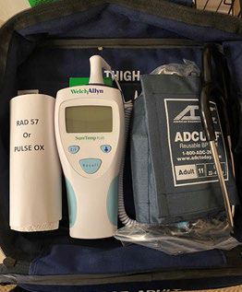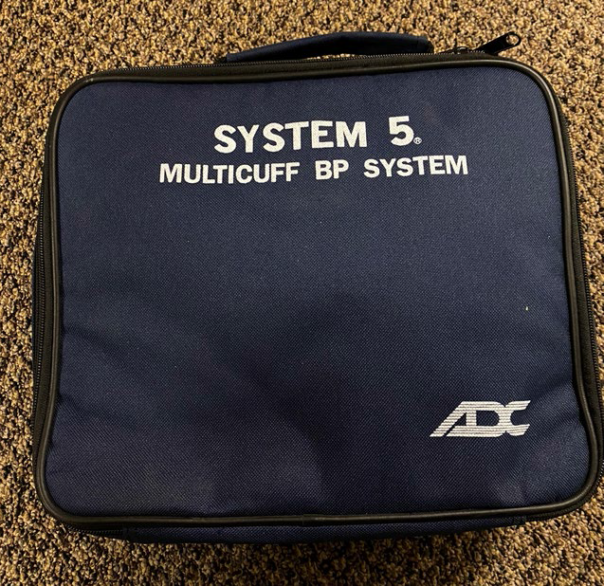1 “Light Vital-Signs” kit for patient assessment (decon between calls)
  - Pulse ox or RAD 57
  - Thermometer (avoid oral temperature, if possible, and alternative equipment available)
  - Blood pressure cuff (adult large)

- main EMS kit (to be left at door) Supplies per responder
  - Case of N95 masks
  - 1 goggle each (can be deconned)
  - 2 boxes of gloves
  - 1 case of gowns
  - 1 Tyvek suit

- Extra uniforms in standby for decon reasons Bunker gear
Decontamination supplies
  - Hand sanitizer
  - Cavicide spray bottles

Alternative Response Unit (ARU)

2 person ARU
- Both responders are in full PPE, but only one responder enters to assess patient. Second responder waits at doorway to not contaminate PPE unless necessary.
“Light Vital-Signs” pack on location for patient assessment.
- Main EMS kit at doorway with 2nd responder.

Assess patient (See Protocol 36A)
If YES to positive critical vitals:
- Request Transport unit ALS or BLS

If NO:
  - Place in queue for low acuity transport

ARU Inventory

1 “Light Vital-Signs” kit for patient assessment (decon between calls)
- Pulse ox or RAD 57
- Thermometer (avoid oral temperature, if possible, and alternative equipment available)
- Blood pressure cuff (adult large)

- main EMS kit (to be left at door) Supplies per responder
  - Case of N95 masks
  - 1 goggle each (can be deconned)
  - 2 boxes of gloves
  - 1 case of gowns
  - 1 Tyvek suit

- Extra uniforms in standby for decon reasons Bunker gear
Decontamination supplies
  - Hand sanitizer
  - Cavicide spray bottles

