12.01.09 INFECTION CONTROL PLAN

1.0 REFERENCE
WAC 296-305-02501
WAC 296-823

2.0 POLICY

2.1 It shall be the policy of The Department to provide a high level of protection against communicable diseases for all members while providing fire, rescue, and emergency medical services.

2.2 Firefighter members shall wear a minimum of disposable gloves and eye protection prior to initiating any patient care.

2.3 Firefighters shall don emergency medical garments (liquid resistant disposable suit or apron) and a face shield over their glasses prior to any patient care in which splashes of body fluids can occur, such as spurting blood or childbirth. |
2.4 Firefighters shall don PPE as recommended by the Center for Disease Control for outbreaks of airborne, viral, or aggressive pathogens.

2.5 The Department shall provide appropriate personal protective equipment, training, and immunization for all members for protection from communicable diseases.

2.6 When the potential for an occupational exposure exists, the employer shall provide, at no cost to the employee, personal protective equipment such as, but not limited to, gloves, gowns, laboratory coats, face shields or masks and eye protection, and mouthpieces, resuscitation bags, pocket masks, or other ventilation devices. Personal protective equipment will be considered "appropriate" only if it does not permit blood or other potentially infectious materials to pass through to or reach the employee's work clothes, street clothes, undergarments, skin, eyes, mouth, or other mucous membranes under normal conditions of use and for the duration of time which the protective equipment will be used.

2.7 The Department shall provide appropriate information prior to, and follow-up health care or any member(s) become involved in an exposure related incident.

3.0 DEFINITIONS

3.1 Bloodborne pathogens: means pathogenic microorganisms that may be present in human blood and can cause disease in humans. These pathogens include, but are not limited to hepatitis B virus (HBV) and human immunodeficiency virus (HIV).

3.2 Confidentiality: The protection of medical information and records of employees and/or patients as defined in medical ethics and federal and state law, which prohibits the release of such information without consent from the individual the information or record pertains to Washington State and addresses the confidentiality of all persons with a sexually transmitted disease including STDs, HIV/AIDS and all bloodborne forms of hepatitis (B, C, and Delta) in Chapter 70.24 -105 RCW and WAC 246-100. Disclosure of STD status is prohibited, with exception of health care providers, including licensed EMS personnel. Agencies with EMS employees must develop written plans and procedures on how to transmit this information in a confidential manner. It can not be transmitted for infection control purposes, only for the care, treatment and benefit of the patient.

3.3 Contaminated: The presence of or the reasonably anticipated presence of blood, body fluid or other potentially infectious materials on an item or surface.

3.4 Exposure: Contact with infectious agents, such as blood and body fluids, through inhalation, percutaneous inoculation, or contact with an open wound, non-intact skin, or mucous membrane that results from the performance of an employee's duties.

3.5 Hospital reportable exposure (unsuspected exposure): A hospital reportable or unsuspected exposure occurs if EMS employees treat or transport a patient who is later diagnosed as having a serious communicable disease that could have been transmitted by a respiratory route. Hospital reportable diseases include tuberculosis and meningococcal meningitis.

3.6 Fire/EMS reportable exposure: A direct introduction of a potentially infectious agent from a patient into the EMS worker's body.

3.7 Infection control officer: An employee or volunteer that is trained and knowledgeable on current medical issues, infection control mandates and practices, state and federal laws (Confidentiality, Ryan White Notification Act, the Americans with Disabilities Act, Federal Civil Rights Laws) and assigned the duties as defined under duties and responsibilities of the fire department infection control officers duties.

3.8 Mucocutaneous (in eye, mouth, or nose): A mucocutaneous event occurs when blood or body fluids come in contact with a mucous membrane Example: Blood or body fluid is splashed or sprayed into the eye, nose, or mouth.

3.9 Percutaneous (through the skin): A percutaneous event occurs when blood or body fluid is introduced through the skin. Examples: needle stick with a bloody needle; sustaining a cut by a sharp object contaminated with blood; entrance of blood or body fluids through an open wound, abrasion, broken cuticle, or chapped skin

3.10 Potentially infectious materials: The following human body fluids: semen, vaginal secretions, cerebrospinal fluids, synovial, pleural fluids, pericardial fluids, peritoneal fluids, amniotic fluid, saliva in dental procedures, any body fluid that is visibly contaminated with blood, an all body fluids in situations where it is difficult or impossible to differentiate between body Fluids.

3.11 Regulated waste: Liquid or semi-liquid blood or other potentially infectious materials; contaminated items that would release blood or other potentially infectious materials in a liquid or semi-liquid state if compressed; items that are caked with dried blood or other potentially infectious materials and are capable of releasing materials during handling; contaminated sharps; and pathological and microbiological waste containing blood or other potentially infectious materials.

.
4.0 RESPONSIBILITIES

4.1 The Fire Chief shall designate an Infection Control Officer. The duties and responsibilities of the fire department Infection Control Officer shall include, but not be limited to:

- Establish protocols for PPE and disinfection of equipment, apparatus, and materials that may be exposed to body fluids.
- The Infection Control Officer shall provide or arrange to provide yearly infectious disease training that covers this program, applicable parts of the Blood Borne Pathogen standard WAC 296-843, disease transmission, cleaning and disinfecting and PPE selection criteria.

- Monitor the compliance to PPE and Cleaning/Disinfection guidelines by spot checks at each station, using the disciplinary policy if necessary to enforce compliance.

- Ensure that exposures are investigated by protocol.
- Shall evaluate the Department's compliance with the infectious disease and exposure program. Devise corrective measures to prevent exposures.

- Ensure appropriate and timely medical follow-up to exposures as required by law and prescribed by the United States Public Health Service.
- The infection control officer or his/her designee will function as a liaison between area hospitals and fire department members to provide notification that a communicable disease exposure is suspected or has been determined by hospital medical personnel.

- Ensure confidential record keeping of all medical prophylactic and post-exposure treatment per chapter 246-100 WAC and the medical protocol requirements of chapter 296-802 WAC..

- Shall approve the release of any related information for whatever purpose.

- Ensure the application of all requirements of the Federal Ryan White Notification Law and act as "designated officer”.
- The infection control officer shall ensure the fire department's compliance with state and federal confidentiality laws.

4.2 In the event of an exposure the Infection Control Officer shall:

- Shall confer with Chiefs for any remedial infection control training that may be needed and schedule such training with the Training Division.

- Shall attach a copy of the Department's exposure form to a copy of the Injury Form when an exposure has occurred to be filed in the member personnel file. The Department shall maintain members personal health files, in a confidential manner, for the duration of employment/membership plus thirty (30) years.

- Shall contact employees and inform them of hospital reportable exposures; and that the test results of EMS reportable exposures are available.

- Shall arrange for initiation of follow-up treatment as required.

- Shall notify members that results of screening for HIV and Hepatitis B are available.

- Shall coordinate the immunization program and maintain records.

- Shall ensure that an adequate infection control plan is developed.

- Shall ensure that all personnel are trained and supervised on the plan.

- Shall establish personnel exposure protocols so that a process for dealing with exposures is in writing and available to all personnel
- Shall institute the established exposure protocols immediately after report of an exposure.

4.3 Members shall be responsible for promptly completing the forms required for reporting an "EMS reportable exposure" and all forms required for any follow-up treatment as listed below:

- Worker Compensation Documentation
- Injury Form
- Pension Board Claim Form
- Pension Disability Accident Report

4.5 Members will be offered Hepatitis vaccinations within the first 90 days of membership. Members may refuse immunization, or may submit proof of previous immunization. Members who refuse HBV immunization will be counseled on the occupational risk of communicable diseases and the ramifications of refusing the immunization and will be required to sign a refusal of immunization statement. Members who refuse immunization may later receive immunization upon request.

4.6 It shall be the member's responsibility to keep their Health History Immunization Record, up to date, at their assigned station with a current copy in their Injury/Illness file.

4.7 Shift Officer in Charge (OICs) shall forward reportable exposures to the Infection Control Officer with completed exposure report form immediately after report of exposure.

5.0 INFECTION CONTROL PLAN

5.1 Training. All members of the Fire Department, prior to assignment and annually thereafter, shall be instructed on protective measures to be taken to minimize the risk of occupational exposure to infectious disease. These topics shall include but not be limited to:

- Education on infectious diseases and modes of transmission;
- Symptoms of infectious diseases;
- Review of Department's infectious disease protocol;
- Recognition of fire service tasks that may create injury or potential for exposure (5.3);
- Explanation of the types, location, proper use and limitations of personal protective equipment,
- Handling, Decontamination, and Disposal of potentially contaminated material
- Explanation of the Hepatitis B vaccine, including information on efficacy, safety, cost (free), methods of administration and benefits of being vaccinated;
- Information on post exposure follow up if exposures occur; and
- Explanation of signs and labels and/or color coding used by the Department.
- An opportunity for questions and answers with the trainer at the time of the training session.
- You must provide additional training when you add or change tasks or procedures that affect the employee's occupational exposure.
            - Note: This training may be limited to the changes in tasks and procedures.

5.2 Records: Written training records shall be maintained for three (3) years after the date on which the training occurred. Information within the record shall include:
- Dates of the session;
- Contents of the session;
- Name and qualification of persons giving the training
- Names and job titles of persons attending the training session.

5.3 Tasks with Potential Exposure: The following job classifications or tasks are areas where members can reasonably anticipate that an exposure to blood, or other body fluids, or other potentially infectious materials have occurred. The examples are not intended to cover every incident to which our members may be exposed.
- Administering emergency medical care to injured or ill patients.
- Rescue victims from hostile environments, including burning structures or vehicles, other contaminated atmospheres, or oxygen deficient atmospheres.
- Extrication of persons from vehicles, machinery, or collapsed excavations, or structures.
- Recovery and/or removal of bodies from any of the above situations.
- Response to hazardous materials emergencies, both transportation and fixed site, involving potentially infectious substances.
- Other job classifications as identified by The Department

5.4 Personal protective equipment.

5.4.1 All operational vehicles, excluding Chiefs vehicles, shall have gloves, eye protection and closeable sharp containers which are puncture resistant and leak-proof.

5.4.2 At a minimum, disposable gloves and eye protection shall be worn during all patient contacts. Members shall select PPE appropriate to the potential exposure.

5.4.3 Facial protection shall be used in any situation where splash contact with the face is possible. Facial protection may be afforded by using both a face mask and eye protection, or a full face shield.

5.4.4 Fire fighting gloves shall be worn in situations where sharp or rough edges are likely to be encountered. Gloves specified in the referenced WAC provide limited protection to bloodborne pathogens. If gloves are exposed to infectious disease they shall be cleaned per policy.
5.4.5 Where possible, disposable gloves shall be changed between patients in multiple casualty situations
5.4.6 Disposable gloves shall not be reused, washed or disinfected for reuse.

5.4.7 EMS PPE Selection Chart (finished by the Infection Control Officer

EMS PERSONAL PROTECTION EQUIPMENT SELECTION CHART
Members shall wear the following PPE when performing the following tasks. Members may opt for a higher level of protection if they consider it necessary to protect themselves from communicable diseases or airborne, bloodborne, or other pathogens. | Required Minimum for all EMS Response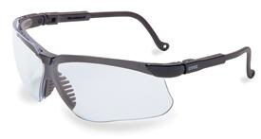 |  | 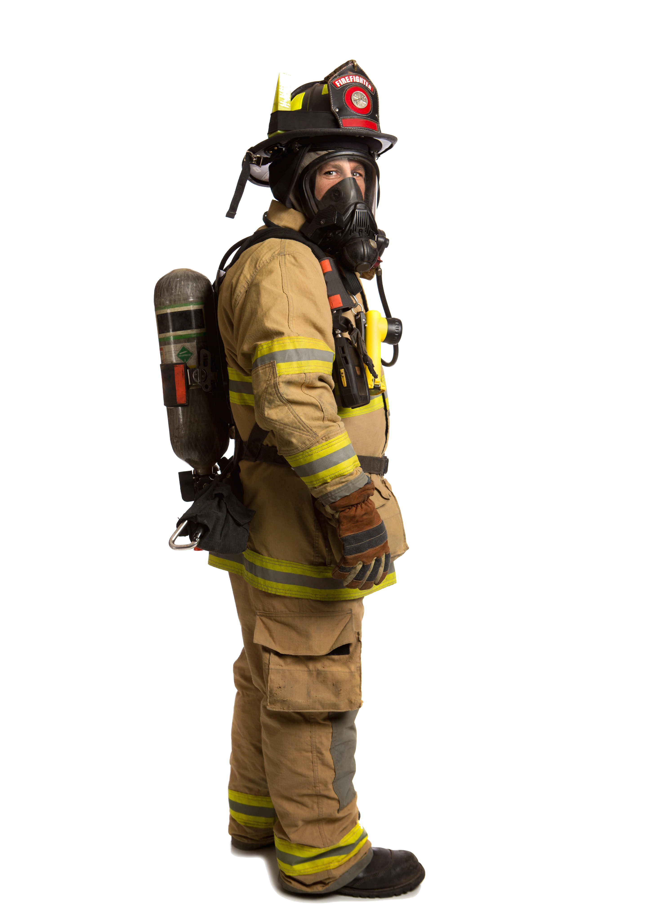 | 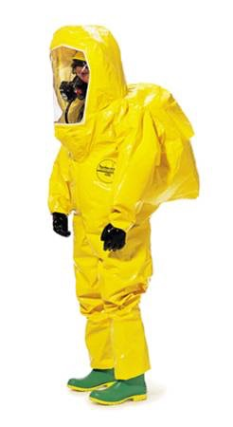
Patient Contact
Potential Spurting Body Fluids
EMS with Potential Highly Contagious Exposure
Disinfecting Apparatus or Equipment

5.5 Returning to Station: Upon returning to quarters after an incident the following precautions shall be observed:

- Contaminated clothing shall be removed and replaced with a clean uniform.
- Contaminated clothing shall be washed as soon as possible upon returning to quarters or placed in a red biohazard bag for future cleaning.
- Contaminated clothing shall be cleaned in the designated cleaning room.
- In accordance with CDC guidelines "Cleaning and Decon" Table S 10/93 all cleaning of contaminated clothing shall be done using a tuberculocidal cleaning agency approved and registered with the EPA.

- In accordance with 296-62-Part 5 Small stains from body fluids shall be spot cleaned and then disinfected.

- Contaminated boots shall be brush scrubbed in the designated area, with a hot solution of soapy water, rinsed with clean water and allowed to dry.
- Members who experience substantial body fluid contact with the skin shall shower as soon as possible upon returning to quarters. This is considered a non-reportable exposure if fluid only came in contact with PPE or intact skin.
- All waste generated during decontamination shall be placed in a biohazard bag and placed in the biohazard disposal area.

5.5.1 All work uniforms shall be washed in the station. Under no circumstances shall contaminated work uniforms be washed at home. Disposable gloves shall be used when handling contaminated clothing.

5.5.2 All members shall be provided and expected to maintain an additional clean uniform in their lockers so that contaminated uniforms can be removed and cleaned upon returning to quarters.

5.5.4 Each station shall establish a designated cleaning area which shall be physically separated from areas used for food preparation, personnel hygiene, sleeping, and living areas.

5.5.5 EMS Disinfecting Guidelines
AFTER EMS CALL DISINFECTING GUIDELINES
Equipment used in Patient Contact or with potential body fluid exposure. | Response Apparatus | Materials (example: gloves, materials that can release bio hazards and other used disposable equipment) contaminated with liquid or semi liquid blood or potentially infectious material, sharps, and pathological or microbiological waste | Used sharps or material with potential body fluids that can cause cuts or punctures.
Wipe down with: | Use (product):  and wipe down all surfaces, door handles, and equipment.  Mop floor with: | Waste must be disposed of in BIOHAZARD BAG.  Clothing and blankets must be cleaned using the following protocol (12.01.09 section 5.5): | Dispose of in a Sharps container.

5.6 Immunizations and history. All members shall be offered and provided the following immunizations or document immunity:

5.6.1 Hepatitis B Vaccine (HBV) One series of three inoculations;

- Booster shots shall be provided in accordance with CDC recommendations;

- Initial HBV inoculations for current members shall be provided at no cost.

- Tetanus-diphtheria inoculations are required every ten years;

- If a puncture wound occurs, a booster is required if it has been seven years or more since last inoculation.

- Measles, Mumps, and Rubella immunization not recommended if you were born prior to 1957;

- Immunization is not recommended for members/employees who are pregnant or anticipate becoming pregnant within three months.

5.6.2 Influenza. Vaccine shall be available from October through February annually will provided members on a voluntary basis.

5.6.3 Tuberculosis. Members shall be provided with regular TB screening, if requested by Member.

5.6.4 Members shall complete a Communicable Disease Health History which shall be updated annually to document immunizations and TB tests.

5.7 Fire/EMS reportable exposures. A direct introduction of a potentially infectious agent from a patient into the EMS worker's body.

5.7.1 Member shall initiate immediate self care with their wound with disinfectant, soap and hot water; flush eyes, nose, or mouth exposures with water or ringer solution.

5.7.2 Members shall make an immediate verbal report of the exposure to their Officer in Charge and initiate a Communicable Disease Report.

5.7.3 Infection Control Officer shall report nature of exposure, identify incident number and patient, and request patient be tested for infectious disease by hospital staff.

5.7.4 Infection Control Officer shall arrange for medical care of members; by a licensed health care professional.

5.7.5 The Health Department shall notify the Infection Control Officer when the results of the patient's blood test are ready.

5.7.6 The Infection Control Officer shall contact member during normal business hours and inform member of test availability and recommended follow-up procedure, self- treated, members shall forward all forms as required for treatment of an occupational injury or illness.

5.7.7 If the hospital recommends immediate care of member after normal business hours, the hospital shall contact the Chief or Safety Officer who shall arrange for the immediate treatment of member.

5.8 Hospital reportable exposures
5.8.1 Hospitals shall notify the Infection Control Officer of all hospital reportable exposures.

5.8.2 The Infection Control Officer shall arrange for the member to receive follow-up medical care as indicated in the exposure follow-up protocols and as recommended by the reporting hospital.

5.8.3 The infection control officer shall contact and inform the member of test availability and recommended follow-up procedures.

5.8.4 If treated, members shall forward all forms as required, for treatment of an occupational injury/illness.

6.0 ADDITIONAL REFERENCES

7.0 APPENDIX
N/A

