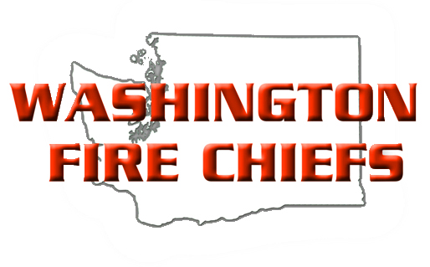

MEMORANDUM OF UNDERSTANDING

Company: Date:
Presenter: Email:
Address: Telephone:
Fax:

This letter will serve as a Memorandum of Understanding between you and the Washington Fire Chiefs, ___________________________Section. Please review all information carefully and comply with the direction given.

CLASS INFORMATION
Your class is titled:
Your class starts on:
Class days are:
Class hours are:
Location:
Topic:

YOUR RESPONSIBILITIES
Travel, Lodging, All Student Materials

WASHINGTON FIRE CHIEFS _________________________ SECTION RESPONSIBILITIES:

The Washington Fire Chiefs ____________________________ Section reserves the right to cancel this Agreement without penalty at any time. Instructor agrees to give at least 30 days’ notice of cancellation to allow sufficient time to obtain a replacement instructor. This Letter of Agreement is a binding agreement and is only valid with the signature of the Washington Fire Chiefs Executive Director or an approved representative with the Executive Director’s approval. No other agreement initiated by either individual will be honored.

If you should have any questions regarding your presentation, please contact _______________________ at (phone number). The Washington Fire Chiefs __________________________ Section is looking forward to a successful conference presentation. Thank you helping make this happen.

PRESENTER WASHINGTON FIRE CHIEFS

Signature ______________________________ Signature _______________________________

Date: _________________________________ Date___________________________________

Please include Class Description and Speaker Bio with this form.

