Community Risk Reduction
Introduction for Fire Department Leaders

Lesson Goal
The goal for the lesson is to introduce community risk reduction components, implementation strategies, and benefits to the participants. In addition the lesson will develop positive attitudes about community risk reduction, and the lesson will create motivation to learn more about community risk management.
Objectives
Upon successful completion of this lesson, the student shall be able to:

- Define community risk reduction, integrated risk management, risk, mitigation, program outcome
- List the socioeconomic and other factors that influence residential fire risk
- List the common fire and emergency response organization’s functions that contribute to delivering community risk management
- List/describe the 5 “E” strategies to mitigate community risk/unintentional injuries
- List four sources of data to assess risk for community risk reduction
- List four community risk reduction community partners
- Recall three examples of community risk reduction outcomes
- Describe the benefits of community risk reduction for the fire and emergency response organization
- Describe the fire officer’s role in community risk reduction
- Summarize community risk reduction as delivered from the fire station for the 1st due response area
- List three sources for more community risk reduction information
- Given a case study/set of community data identify risks and strategies to impact the risk
- Given a community risk reduction plan case study identify the benefits of the plan and ways implement in the organization

Instructor Information
This lesson is an introduction to community risk reduction presented through actual case studies. The lesson of covering the introduction to hazardous materials for Awareness-Level personnel. This lesson describes the roles and responsibilities of the Awareness- and Operations-Level personnel, and describes the hazards and routes of entry of various hazardous materials. In addition, the chapter discusses statistics of hazardous materials incidents and describes the regulations and definitions of the United States, Canada, and Mexico.

Important instructor information is provided in shaded boxes in this Instructor Guide. These boxed describe the instructional methods. Carefully review the instructor information before presenting the lesson.
Methodology
This lesson uses lecture, guided discussion and small group activities. The level of learning is comprehension in the cognitive and affective domains of learning.
Estimated Total Time: 4 hours

Time | Section/Activity | Outline Pages | Text Pages
10 min. | I: Participant Introductions
5 min. | II: Lesson Goal and Learning Objectives
20 min. | III: Preparing Participants to Learn
5 min. | IV: Community Risk Reduction Terms
40 min. | V: Britain Case Study
50 min. | VI: CRR Model
50 min. | VII: Benefits of CRR
50 min. | 1 CRR Solutions to Real Problems
5 min. | Chapter 1 So You Want to learn more
Audiovisuals
- Visuals 1.1 to 1.47 (PowerPoint® Presentation)
- Easel pad and marker or white board
- Timer
- 3x5 Cards
Participant Handouts
- Chapter 1 Quiz
- Chapter 1 Test

I: Welcome and Participant Introductions 10 min.

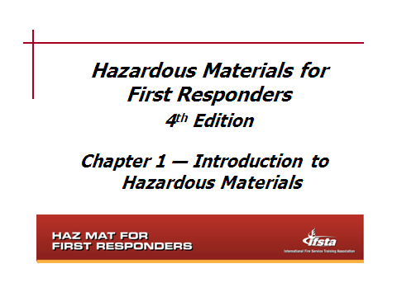
Wecome and introductions
Instructor Note: This needs to be quick. Do not elaborate at this time in the lesson. Record the mission/responsibilities from the participants on poster paper. Post these in the room for reference throughout the lesson. The goal of this exercise is to have a list of fire officer responsibilities, all of which are enhanced (made better, improved) with CRR.
Expected Responses
Save lives
Keep firefighters safe
Pre-fire planning
Serve the people in our community
Firefighter safety
Ready to respond
Code enforcement
Do more with less

Have each participant introduce themselves and report one part of the mission of their organization and/or one responsibility of their position. The question can also be phrased

Instructor Note: Assess student entering level of CRR knowledge. Some may have been to the NFA or read more and can lead the class to more advanced information concerning CRR. Many may have no experience.
Section II: Lesson Goal and Learning Objectives 5 min.

goal and objectives
Instructor Note: The purpose of this section is to present the lesson goal and the objectives.

Define community risk reduction, integrated risk management, risk, mitigation, program outcome
Power point picture

List the socioeconomic and other factors that influence residential fire risk

List the common fire and emergency response organization’s functions that contribute to delivering community risk management

List the five “E” strategies to mitigate community risk/unintentional injuries

List four sources of data to assess risk for community risk reduction

List four community risk reduction community partners

Recall three examples of community risk reduction outcomes

Describe the benefits of community risk reduction for the fire and emergency response organization

Describe the fire officer’s role in community risk reduction

Summarize community risk reduction as delivered from the fire station for the 1st due response area

List three sources for more community risk reduction information

Given a community risk reduction case study identify the benefits of the CRR project, key steps and people in the implementation and identify who is responsible for each step of the CRR Planning template that guides the project

Section III: Prepare the Participants to Learn 20 min.

prepare to learn
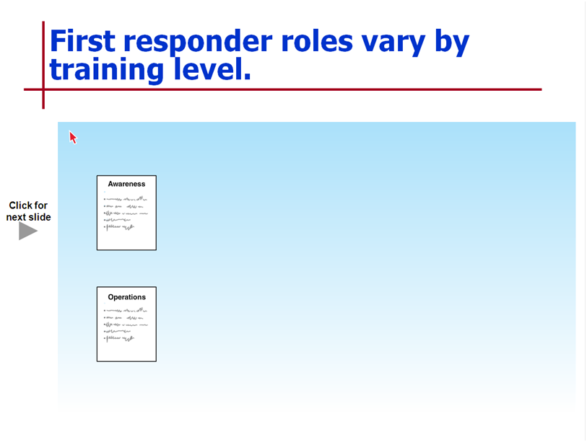
Instructor Note: This section is a brief lecture followed by a guided discussion, small group activity, or individual activity.

Definition of prevention, risk, mitigation,

Prevention strategies
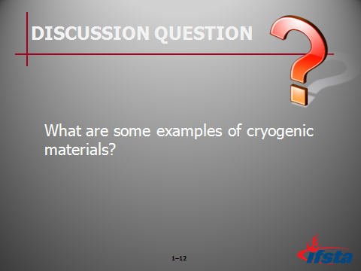
Ask Students: What are some examples of Education as a prevention strategy? Take their comments and then reveal the ones on the slide. Note that educational gain must be the goal. It is different than public relations or public information

Education

Knowledge gain and behavior change

Not just a brochure
Ask Students: What are some examples of Engineering as a prevention strategy? Take their comments and then reveal the ones on the slide.

Engineering

Smoke alarms, child passenger seats

Other examples
Ask Students: What are some examples of Enforcement as a prevention strategy? Take their comments and then reveal the ones on the slide. This should be very quick as a review of what most already know.

Enforcement

Codes and standards

Enforcement/compliance

Regulations

Air bags in cars
Ask Students: What are some examples of Economic Incentives as a prevention strategy? Take their comments and then reveal the ones on the slide.

Economic Incentive

Tax credits

Construction tradeoffs for home fire sprinklers
Ask Students: What are some examples of how Emergency Response as a prevention strategy? Take their comments and then reveal the ones on the slide. Mitigation is goal not just prevention.

Emergency Response

Mitigate loss of life & property

Use scenarios to match the “E’s” to mitigate the risk/loss
Instructor Notes: There are scenarios for a participant activity. The participants in a guided discussion, small group or individual activity identify as least two of the “E’s” to mitigate the loss/risk. Groups have 5 mins to read the scenarios and match to “E’s”. Groups then report to the class
Divide a class of 24 people into groups of 4. Assign each group scenario names or numbers. The groups have 5 minutes to choose how to mitigate risk/loss. Each group reports back to the class. Use the timer to keep on track.

Conclude this section with the summary – CRR is targeting risk/loss with interventions at the lowest level/route cause possible in the organization. Intervention for home fires is education, and engineering in the home. Let’s see how it has been done successfully.

Section IV: Community Risk Management Terms 10 min.

terms and definitions
Instructor Note: The definitions are posted in the room and are in the participant handout. This is a quick review and summary.
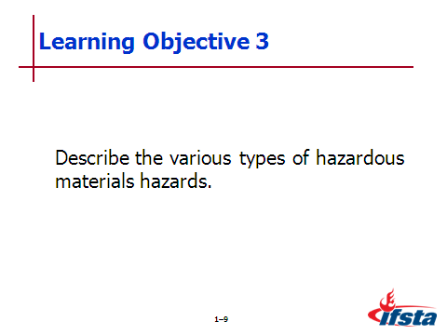

Definitions

Acute

Acute health effects

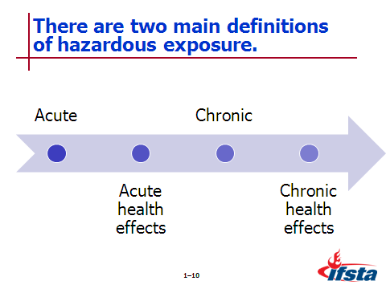
Chronic

Chronic health effects

Hazard
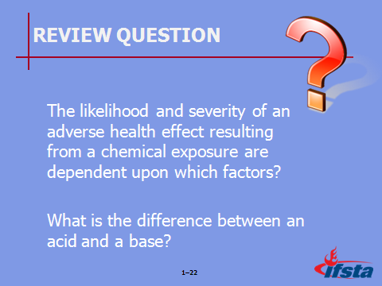
Review Question: The likelihood and severity of an adverse health effect resulting from chemical exposure are dependent upon which factors?
What is the difference between an acid and a base?
See pages 23-27 of the manual for answers.

Section V: What is Community Risk Reduction and
How Does It Work-A Case Study 40 min.

CRR Case study: Britain
Instructor Note: This is a small group activity using the Britain Case Study and Study Guide. Each participants needs a copy. Groups will have 20 minutes to complete. Bring the class together to present their responses. See the instructor key for recommended answers.

Instructor Note: The following list of three main routes of entry is put forth by the Centers for Disease Control (CDC) and the National Institute for Occupational Safety and Health (NIOSH).
Section VI: The Community Risk Reduction Model 50 min.

CRM Model
Instructor Note: Terms are used interchangeably. For this section the CRR term will be used to present the concepts of the model.

Instructor Note:

Vision, Mission, Values and Priorities

Describe Your Servcie Area

Geographic Boundaries

Land Use

Type of occupancies

Age of structures

Condition of structures

Zoning

Demographics

Populations

Race

Languages other than English

Ages (children and older adults)

Family types and household size

Income

Education

Community Assets

Churches

Associations

Businesses

Community Concerns

Station Demand

Firefighters per 100,000 population

Calls per firefighter

Average daily call load per shift

Calls per 100,000 population

Average Response Time

Fire

Medical

All

Patient Treatment

EMT/Paramedic service

Patients refusing treatment

Patients transported

Fires

Structures

Vehicles

Outside/others

Causes of Fire

Civilian fire deaths and injuries by property use

Property loss by property use

Response distances – furthest

High frequency users

Who and what they call about

Identify Risks

Prioritize Risks

Mitigation Strategies

Implement CRR

Monitor and Evaluation
Ask Students: What is a process?

Briefly discuss answers with students.
Ask Students: What are?

Briefly discuss answers with students.

Section VII: Benefits of CRR 60 min.

Benefits of CRR
Instructor Note: The purpose of this section is to review

Section VIII: CRR Solutions to Real Problems 50min.

SUMMARY AND REVIEW
Instructor Note: The purpose of this section is to summarize the lesson and review key points. Answer any questions students may have about the lesson or course in general.
Section XIV: So YOU Want to Know More 5min.

