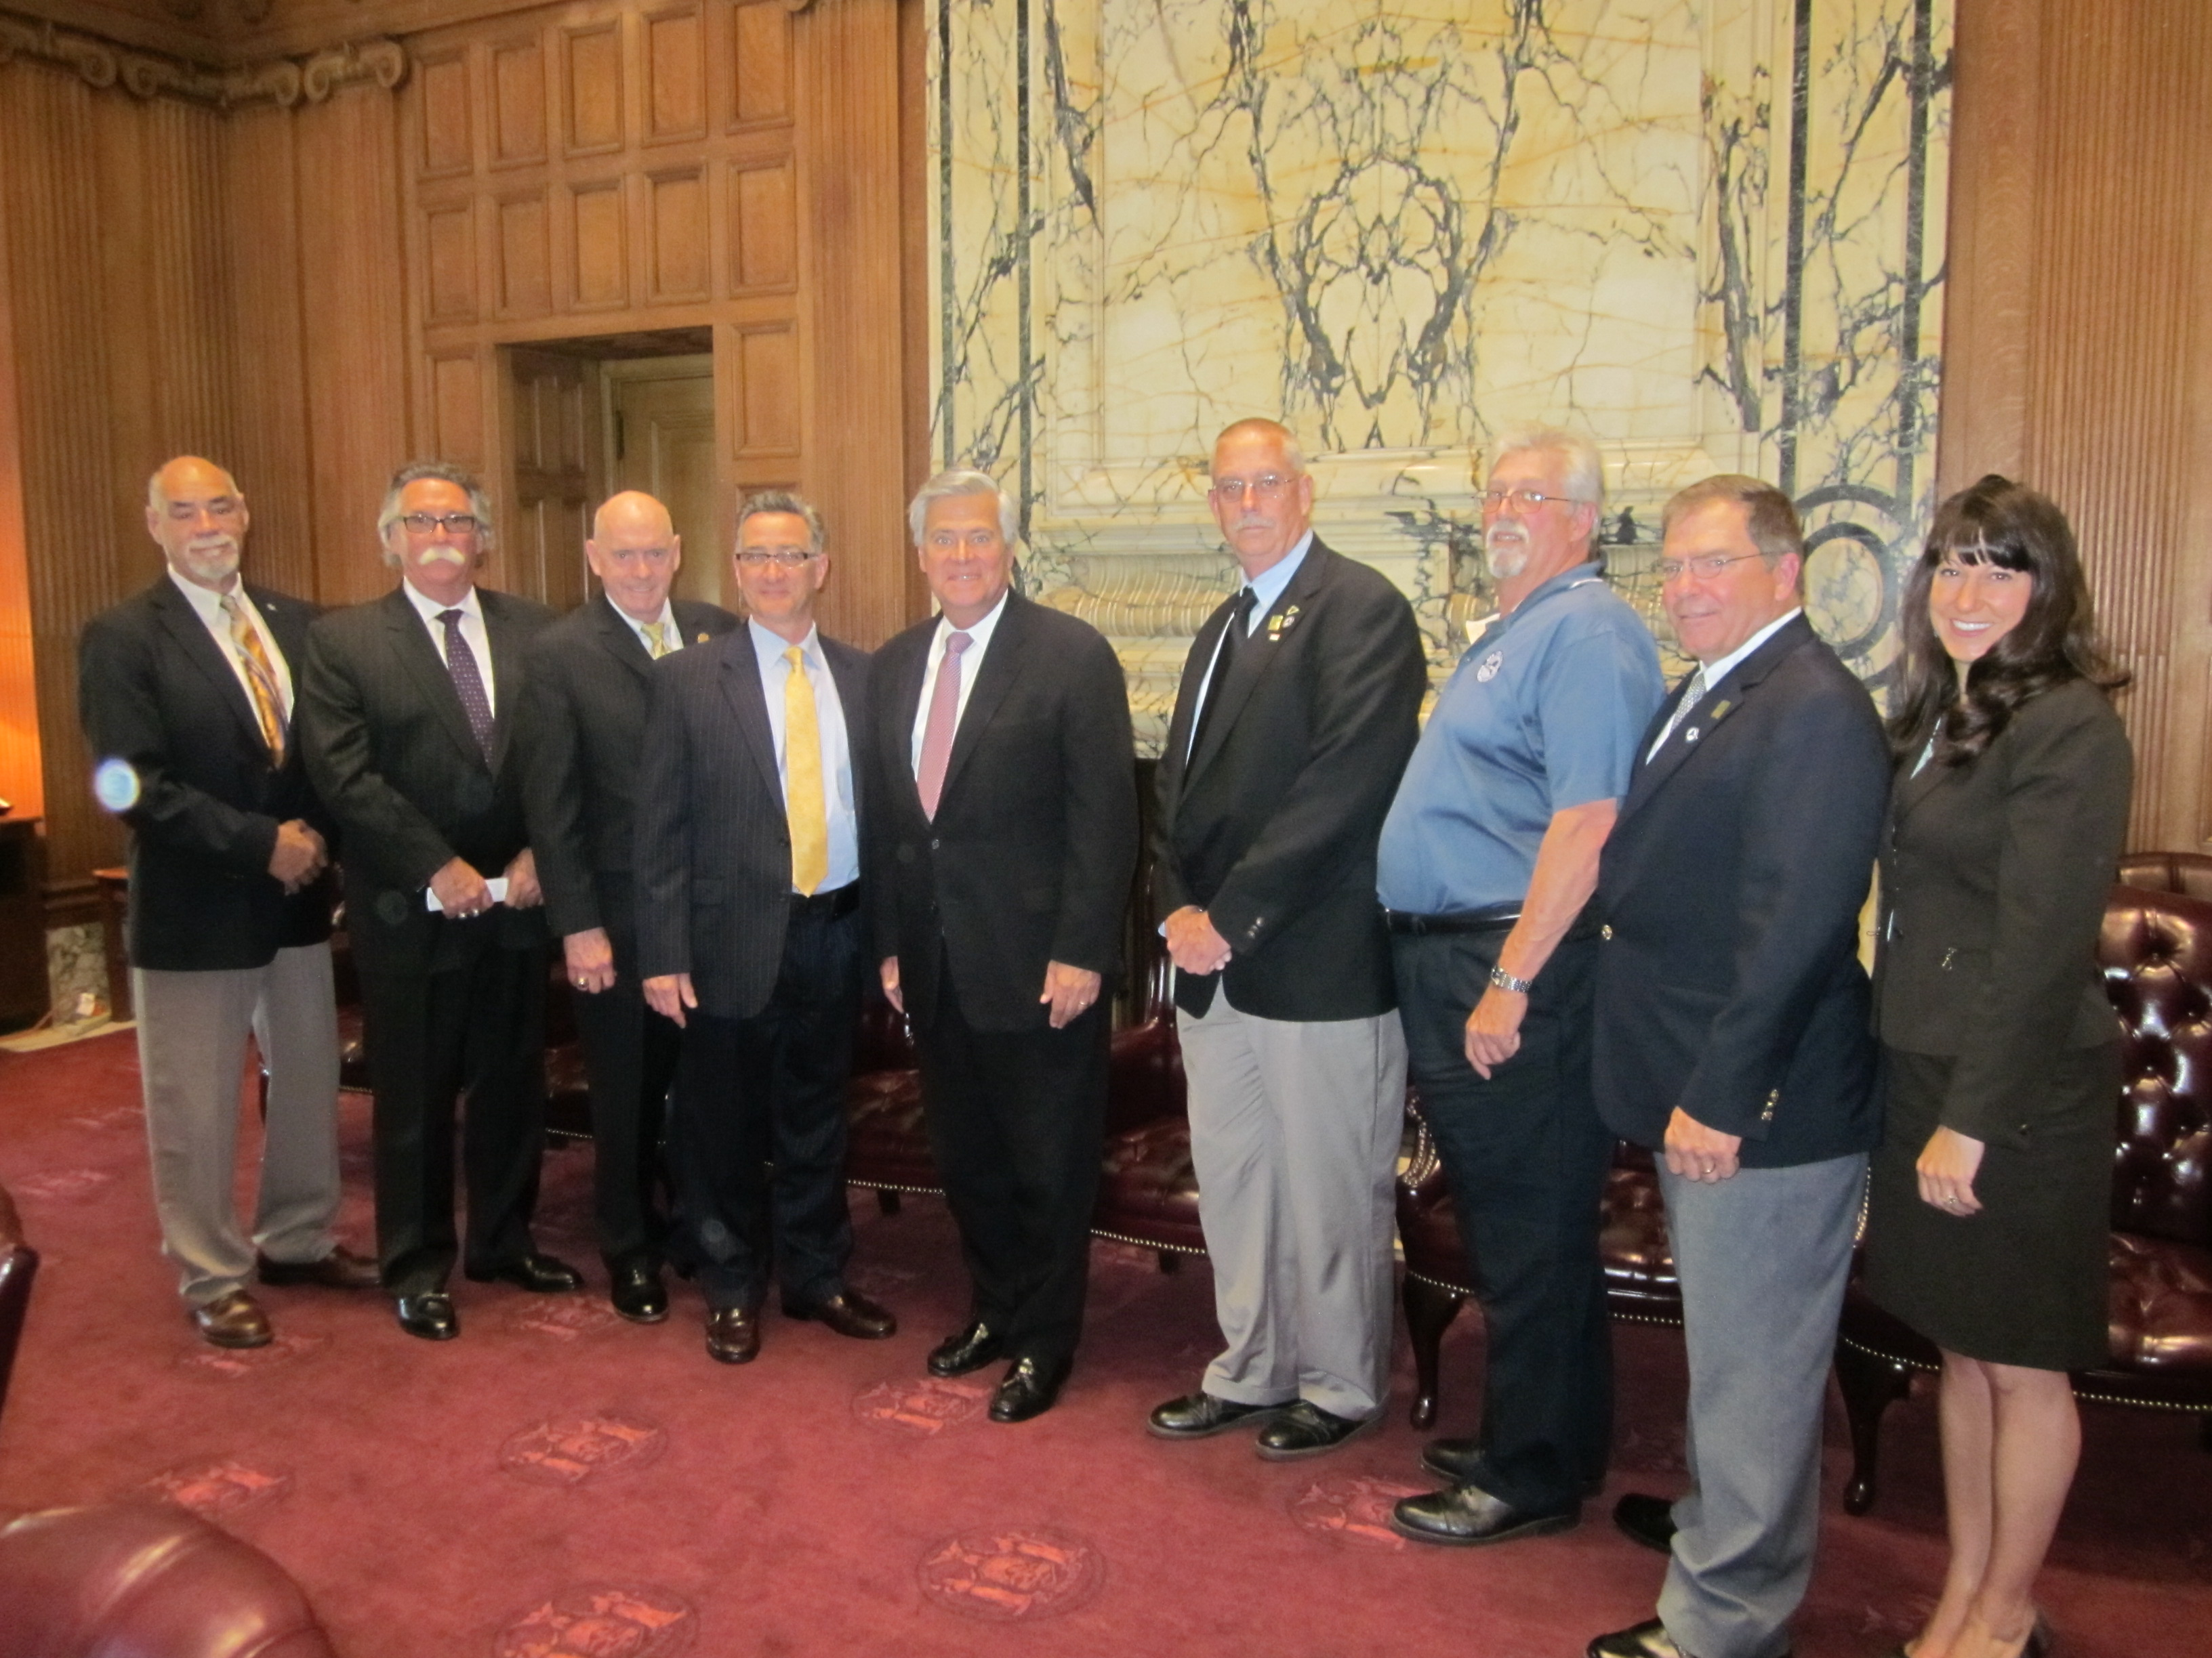

Creating a Lobby/Advocacy
Day during Building Safety Month

Determine who within your chapter will be attending and schedule meetings with Legislators of constituents in attendance. Usually the first question the Scheduler has is “what is the name of the constituent the Senator will be meeting with?”

In preparation, learn the names /faces of your elected officials AND of those who Chair or who are on the important Committees – even if you aren’t meeting with them that day, you still might run into them in the hallway

Learn the Legislative Calendar- no sense discussing a $$$ issue after the budget passed

Know your audience – dress, act and speak accordingly. For dress codes, when in doubt dress professional – business attire or in uniform

Prepare a “leave behind” document which summarizes your issues

Brevity – Be able to express your point in 1-2 minutes. You may have a ½ hr meeting scheduled and instead wait 20 minutes for the Legislator to return to their office, so be prepared to get your point across quickly. Keep in mind that no one understands building safety/code enforcement the way we do; FOCUS on key elements which are easy to understand – assume they know nothing!

Passion – if you are passionate they will be (or at least remember the issue or you!). Remain positive – let them remember a competent, cheerful, concise and respectful voter

Do not argue or contradict – always be respectful of their viewpoint. Instead, “show them the light” through reason, education, etc… Also, use real-life examples: tell a tragic, heartwarming or funny story or anecdote which conveys your issue

Respect Staff - treat them as you would treat the Legislator. In most cases they are the primary persuader (and the one with the ear of the Member throughout the day)

Bring a camera – get a picture & use it in a newsletter (yours, theirs, ICC e-news)

Send a thank you note – this is a gentle reminder of the issues you discussed and could lead to a follow-up meeting

Dottie Harris, ICC Gov’t Relations
&
Bob Cordell, NYSBOC Leg Committee

