Chelan County Fire District 5
250 Manson Blvd. – P.O. Box D
Manson, WA 98831
PH: 509-687-3222
www.chelan5.org
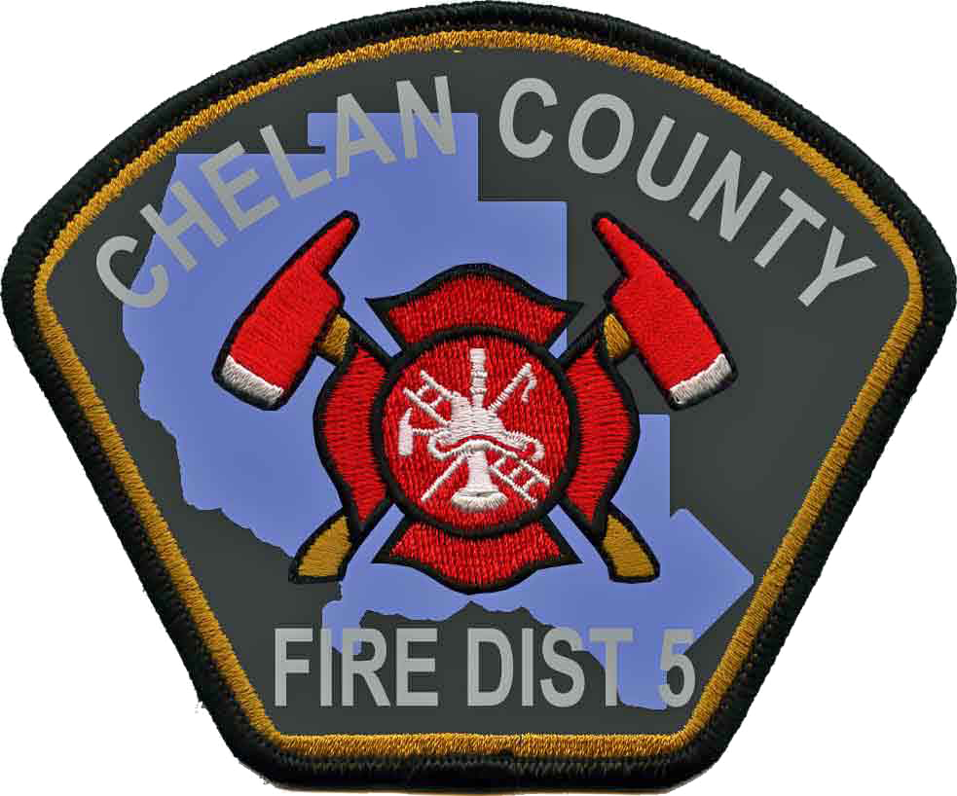

Press Release
For Immediate Release

Date: March 12, 2013
For more information contact: Arnold Baker, Fire Chief - 509-687-3222

Chelan County Fire District 5 to Launch Free Smoke Alarm Program
Keeping Citizens Safe from Fire

MANSON – Starting in March and running through June 2013, firefighters with Chelan County Fire District 5 will be out in the community visiting local residents and inviting them to participate in a free smoke alarm installation and home safety program.
This program, made possible through a grant from the Washington State Association of Fire Marshals is part of a community-wide fire prevention effort designed to reach out to local residents, including seniors, families with young children and residents of neighborhoods, who are most vulnerable to fire deaths. According to the National Fire Protection Association (NFPA), roughly 70 percent of home fire deaths in the country result from fires in homes with no smoke alarms or no working smoke alarms. “Smoke alarms are the most effective early warning device there is,” says Arnold Baker, Fire Chief. “Just having working smoke alarms in your home can cut your chance of dying in a fire nearly in half.”

The ultimate goal of this program is to make sure local residents have the needed protection provided by working smoke alarms. Since smoke alarms have a life expectancy just like many other mechanical devices, firefighters will be replacing old and non-working smoke alarms with new 10-year lithium battery powered smoke alarms. They will also be providing the latest technology available in both photo-electric and ionization alarms, each designed to alert the presence of smoke differently.
Since the fire department recognizes that smoke alarms alone won’t prevent every fire death, the project also includes educating residents during the visit about the importance of having a home fire escape plan. Firefighters will also conduct a brief home safety survey designed to help residents identify possible fire hazards in their home and ways to mitigate them, which can ultimately assist with reducing the risk of a fire occurring.

Residents in the community are encouraged to take advantage of this exciting life saving service being provided free of charge. During the smoke alarm installation program, local firefighters will fan out through the area, visiting residents in a number of identified neighborhoods. Residents who wish to schedule a home visit and receive free smoke alarms can do so either when firefighters stop by or by calling the fire station.

Please feel free to contact the fire department at 509-687-3222 for more information on this program and ways you can keep your home and family safe from fire.

-###-

