Oct. 25, 2018

Washington State Association of Fire Marshals

SOCIAL MEDIA – “BALANCING” FIRE DEPARTMENT POLICIES vs. FIRST AMENDMENT RIGHTS

Mock Trial

Lawrence T. Bennett, Esq.
Cincinnati, OH
Lawrence.bennett@uc.edu
lbennett@katzmanlaw.ciom
Cell 513-470-2744

Free FIRE & EMS LAW newsletters (send me e-mail if wish to receive): https://ceas.uc.edu/aerospace/FireScience/fire-ems-safety.html
TEXTBOOK: EMS LAW (Second Edition): June 2018; FREE ONLINE TEXTBOOK: (ISBN: 978-1-949104-03-5); https://scholar.uc.edu/concern/generic_works/6m311p85h (First Edition, 2012, MBS Direct, Columbia, MO).
TEXTBOOK: FIRE SERVICE LAW (Second Edition): Jan. 2017 (ISBN 978-1-4786-3397-6); Waveland Press: http://www.waveland.com/browse.php?t=708 (First Edition – Prentice Hall, 2008)

MOCK TRIAL
May 11, 2018: “The city didn’t like her Ferguson post, so they fired her. Now it must pay $1.5M.”
https://www.charlotteobserver.com/news/politics-government/article150006207.html

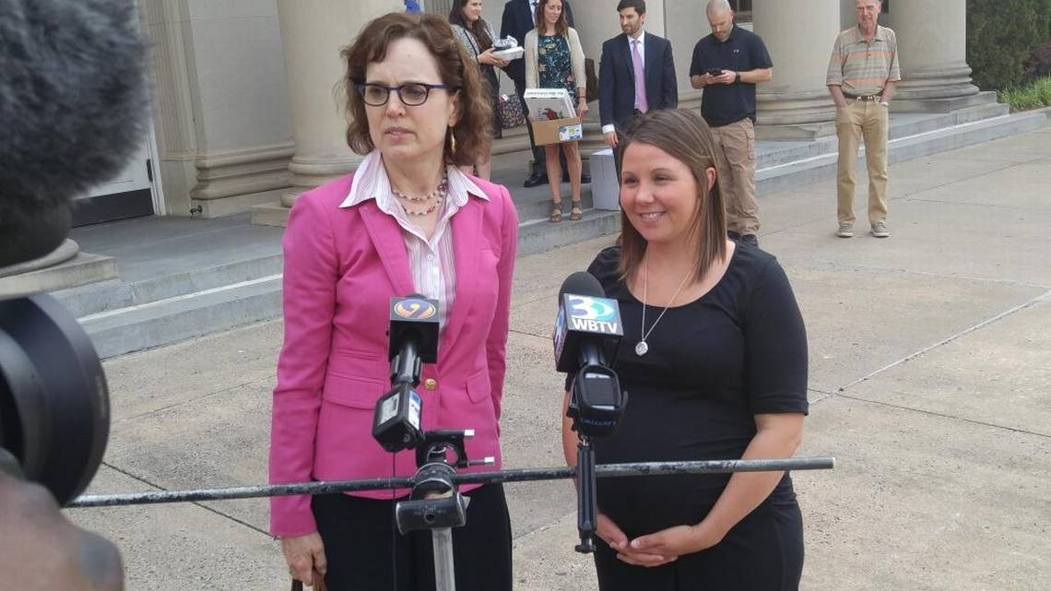Former fire investigator Crystal Eschert, right, and her attorney, Meg Maloney, speak to reporters Thursday after a jury awarded Eschert $1.5 million in her lawsuit against the city. Steve Harrison sharrison@charlotteobserver.com

June 2, 2017: “Judge upholds $1.5 million Facebook post verdict.”
http://www.charlotteobserver.com/news/politics-government/article154126809.html

Oct. 25, 2017: “City Of Charlotte And Former Fire Investigator Settle Retaliation Lawsuit.” A former fire investigator who brought a retaliation lawsuit against the City of Charlotte will receive $1.1 million as part of a settlement.
http://www.wfae.org/post/city-charlotte-and-former-fire-investigator-settle-retaliation-lawsuit#stream/0
[From June 2, 2017 article.]
“Chief U.S. District Judge Frank Whitney upheld Friday last month’s $1.5 million judgment against the city of Charlotte, a further setback to the city..
A jury awarded former fire investigator Crystal Eschert $1.5 million because it found the Fire Department retaliated against her for complaining about the quality of renovations at a new office building renovated for Eschert and her colleagues. The city said that wasn’t true.
Charlotte said she was fired for what it said was an offensive Facebook post made after riots in Ferguson, Mo. in 2014. The post said: “White guy shot by police yesterday near Ferguson … Where is Obama? Where is Holder? Where is Al Sharpton? Where are Trayvon Martin’s parents? Where are all the white guys supporters? So is everyone MAKING it a racial issue? So tired it’s a racial thing. If you are a thug and worthless to society, it’s not race – You’re just a waste no matter what religion, race or sex you are.”
Eschert and her attorney, Meg Maloney, said the city created a fake internet persona to complain about the post to discredit Eschert.
The jury made its decision May 11. Whitney didn’t make a judgment on the case immediately, citing a number of technical issues with the trial.
The city argued the verdict would be overturned, and many people in the Government Center believed the jury had gotten the case wrong.
Whitney wrote that “the Court concludes.....that Plaintiff’s building complaints constituted protected speech under the First Amendment.”
Maloney said she wasn’t surprised.
“We expected this result by the judge, that he would honor the jury’s verdict,” she said.
The city said Friday it’s unclear whether Eschert will receive the full $1.5 million and that Whitney has not ruled on damages.
It also must now decide whether it will appeal to the Fourth Circuit Court of Appeals. That will likely be an issue for Mayor Jennifer Roberts and the City Council to decide.”

https://www.phoenix.gov/firesite/Documents/fire_mp_10518.pdf

PHOENIX FIRE DEPARTMENT

Social Media Policy 06/15

Questions regarding this Social Media policy may be directed to the Public Affairs Section at 602-534-0953.

POLICY STATEMENTS – All Employees

1.Personal Social Media Presence. Employees may express themselves as private citizens on social media sites. An employee’s use of any social media site must comply with copyright laws, data security and privacy regulations, criminal laws, and any other applicable federal, state, and local law.

5. Perception. With social media, the lines between public and private, personal and professional can be blurred. *** Employees must not represent or speak on behalf of the Phoenix Fire Department on their personal social media sites when they are not authorized to do so. Employees must not give the appearance that they are speaking on behalf of the department or posting comments as an official Fire Department representative on personal social media sites, when they are not authorized to speak on behalf of the department.
This perception may be avoided by choosing to not post work-related information, featuring themselves while wearing a Phoenix Fire Department uniform or displaying the City logo, public safety patches, badges, or Phoenix Fire Department vehicles on a personal site –
especially in profile images. These actions could cause people to
believe employees are posting as authorized Phoenix Fire Department
spokespersons, official department representatives, or on behalf of the City of Phoenix.

RECENT “WAR STORIES”

Aug. 16, 2018: NY - NY Fire Chief Terminated After Racist Facebook Post - East Syracuse Fire Chief Jim Brewster was has been removed as the village's fire chief by its board of trustees after he used a racial slur in a comment on Facebook.
https://www.firerescue1.com/racism/articles/389340018-NY-fire-chief-terminated-after-racist-Facebook-post/?NewsletterID=995989&utm_source=iContact&utm_medium=email&utm_content=TopNewsRight1Title&utm_campaign=FR1Member&cub_id=%5Bcub_id%5D

June 27, 2018: WA - Local EMTs Put On Unpaid Leave Due To "Culturally Insensitive" Comments - Yakama Nation Chairperson Jode Goudy has urged the public to share the comments made by two local EMTs who commented on a photo of a Native American boy, wearing a shirt that read, 'No one is illegal on stolen land.' In response to the photo, one EMT said, 'For God sakes. It’s not stolen, you were conquered, shall we finish the job.' And another EMT posted, 'I’d love to shoot a crossbow into his face.' He adds, ‘I’d have more respect for them if 98.9 percent of them weren’t so useless and a sorry excuse for a human being. '
http://kimatv.com/news/local/local-emts-put-on-unpaid-leave-due-to-culturally-insensitive-comments

March 22, 2018: FL - Cop Under Scrutiny Over Social-Media Posts That Call Parkland Students 'Paid Actors’- A police officer is under investigation in connection with social-media posts suggesting the Parkland school massacre could be a hoax — and the students “paid actors” instead of survivors. “What proof do you have?” asks a post under the name of Ericson Harrell, a North Miami Beach police officer. “What evidence do you have, that anyone was killed other than #MSM accounts, alleged witnesses and a couple of funeral processions?” http://www.sun-sentinel.com/local/broward/parkland/florida-school-shooting/fl-sb-ericson-harrell-north-miami-beach-police-20180406-story.html

March 15, 2018: OH - Ex-Springfield Firefighter Shared Post With Racial Slur - A Facebook post shared by a Springfield firefighter that the city says led to his firing contained a racial slur, and mocked school dropouts and McDonald’s employees. Bradley Baugh was fired on March 9 after only a few weeks with the Springfield Fire/Rescue Division, according to city records obtained by the Springfield News-Sun through a public records request. *** A screen shot of the post obtained through a public records request from the Springfield fire division appears to show Baugh shared a meme on March 3 that uses a racial slur, saying they “dropout of school & get a job at McDonald’s talking bout ‘On My Grind’ Yeah, okay, GRIND me up a Oreo Mcflurry with yo (expletive).” https://www.springfieldnewssun.com/news/local-govt--politics/read-now-springfield-firefighter-shared-post-with-racial-slur/oBxBPhyMiHPERdliM66TRM/
RECENT COURT DECISIONS
FROM MY FIRE & EMS LAW NEWSLETTERS https://ceas.uc.edu/aerospace/FireScience/fire-ems-safety/chapter_16_-_discipline.html
Article 16-42 (Aug. 31, 2018)
TX - Free Speech - PD Officer Fired After Organizing Police Association - Police Chief No Qualified Immunity
On Aug. 31, 2018, in Marcus Mote v. Debra Walthall, the U.S. Court of Appeals for 5th Circuit held (3 to 0) that Police Chief Debra Walthall is not entitled to qualified immunity, and Officer Mote’s lawsuit against her may proceed. Officer Mote sought before he was fired to organize police officers with the City of Corith, TX into a “Corith Police Officers Association” [no collective bargaining rights under TX law], affiliated with the Texas Municipal Police Association. The Court wrote, “The First Amendment protects the right of all persons to associate together in groups to ‘advanc[e] beliefs and ideas.’ Put another way, ‘the [F]irst [A]mendment protects the right of all persons to associate together in groups to further their lawful interests.’ When groups gather together for this purpose, ‘it cannot be seriously doubted’ that they comprise associations protected by the First Amendment. *** We conclude that Mote’s right to speak in furtherance of forming the CPOA was clearly established as an integral part of his association rights. *** We agree with the district court that Mote’s association and speech rights to engage in the activities he alleged were clearly established. We therefore DISMISS the appeal.” https://cases.justia.com/federal/appellate-courts/ca5/17-40754/17-40754-2018-08-31.pdf?ts=153573667

Article 16-40 (June 12, 2018)
PA - Social Media - DOT Employee Fired For FACEBOOK Posts About School Bus Drivers - Reinstated, No Harm To DOT
On June 12, 2018, in Rachel L. Carr v. Commonwealth of Pennsylvania / Department of Transportation and Civil Service Commission, the Commonwealth Court of Pennsylvania held (3 to 0) that the employee’s FACEBOOK posts about local school bus drivers were “inappropriate” but were protected since it “touched on a matter of public concern.” The Court wrote: “After a thorough review of the record and a conscientious analysis of the factors articulated by the United States Supreme Court, we conclude that the Department’s generalized interest in the safety of the traveling public does not outweigh Carr’s specific interest in commenting on the safety of a particular bus driver. While Carr’s comments are undoubtedly inappropriate, such comments still receive protection under the First Amendment.” http://www.pacourts.us/assets/opinions/Commonwealth/out/380md17_6-12-18.pdf
Article 16-35 (Jan. 25, 2018)
WA - Captain fired for repeatedly posting e-mails on religion - no FD policy on written communications - lawsuit reinstated
On Jan. 25, 2018, in Jonathan J. Sprague v. Spokane Valley Fire Department, et al., the Supreme Court of the State of Washington, held (5 to 4) that “Sprague has met his initial burden to show that SVFD's restrictions on his speech violated the First Amendment. On remand, the burden will shift to SVFD to show by a preponderance of the evidence that it would have reached the same decision as to respondent's employment termination even in the absence of the protected conduct.” https://caselaw.findlaw.com/wa-supreme-court/1887047.html

Article 16-33 (Jan. 11, 2018)
IL - Social Media posts by Deputy Fire Chief - fired - lawsuit dismissed, not protected by First Amendment
On Jan. 11, 2018, in Richard Banske v. City of Calumet City, U.S. District Court, Northern District of Illinois (Case No. 17C5263), Judge Harry D. Leinenweber granted City’s motion to dismiss. “[A] policymaking employee may be discharged ‘when that individual has engaged in speech on a matter of public concern in a manner that is critical of superiors or their stated policies.’ Hagan, 867 F.3d at 826 (quoting Kiddy-Brown v. Blagojevich, 408 F.3d 346, 358 (7th Cir. 2005)). *** Without well pled factual allegations, the Court is left to guess whether Banske's at-issue speech touches upon a subject of public concern. This the Court will not do. The Complaint fails to establish that Banske engaged in constitutionally protected speech, so it fails to state a claim upon which relief may be granted.” https://www.leagle.com/decision/infdco20180112a43

