Residential Fire Sprinklers
and their
Impact to the Fire Service System
In Washington State
Declaration
Of
Larry Rabel
Captain, Strategic Planning Unit, Kent Fire Department
President, Deployment Dynamics Group
9/24/2009

This white paper is prepared for the Washington Building Code Council as testimony in opposition of the amendments offered by the Washington Building Industry that would eliminate residential sprinklers in the International Residential Code.

Table of Contents
Introduction 3
Situation of Washington’s Fire Service 3
Fire Service System Concept 4
The Problem 5
Mitigation; The Solution 6
Summary 6
Closing Statement 9

Table of Figures
Figure 1 NFPA 550 Figure 4.3 Top gate of Fire Safety Concepts Tree 5
Figure 2 Time verse Products of Combustion & Restriction of Fire Growth by Automatic Fire Sprinklers 7

Introduction
Fire sprinklers are a necessary mitigation tool for Washington’s fire departments. Statewide, fire departments are expected to provide adequate levels of service as called out by the State Legislature in the Growth Management Act (GMA) RCW 36.70A, the State Subdivision Code RCW 58.17, State Codes regulating cities RCW 35.103 and 35A.92, and in the State Code regulating fire districts RCW 52.33. State guidelines for fire service performance and adequacy of service utilizes benchmarks established by the National Fire Protection Association (NFPA) for fire protection. Time is the benchmark, free burning fires will double in size every minute they are allowed to burn unchecked. As a fire is allowed to burn, it gives off smoke and toxic gases and reaches a point in fire development called “Flashover”. Flashover is an almost explosive transition in a structure fire where all of the contents within a room instantly burst into flame and survival in the fire compartment is no longer possible even for fully protected firefighters. The time portion of adequate fire services is the race to intervene in the development of fire prior to flashover.
RCW 35.103, 35A.92 and 52.33 all state that predominantly career fire departments shall establish level of service objectives that are meaningful to flashover. These same fire departments are also guided by a national set of standards established by the National Fire Protection Association (NFPA). NFPA’s Standard 1710 establish level of service standards for career fire departments and NFPA 1720 establishes level of service standards for volunteer fire departments.
The US Census Bureau lists Washington State as the ninth fastest growing state and projects a 46% growth rate between 2005 and 2030. As this period of rapid growth occurs, fire departments in Washington State will be bound to maintain levels of service. At the same time, these fire departments will see their public service role continue to expand. Today’s post September 11th 2001 Washington State firefighter is called upon to be an all hazards expert for any emergency faced by our communities. In addition to firefighting, Washington’s firefighters are called upon to provide emergency medical services, auto accident extrication, hazardous materials response, homeland security planning and response, emergency management planning and response, rope rescue, water rescue, confined space rescue, and any multitudes of services that are not specifically performed by other public agencies. Today, if you need help that does not fall into the category of police response, and you call 9-1-1, it is likely that you will be sent a fire department crew to help. As a result of the public demand for these services, the burden placed upon Washington’s fire service is placing an enormous strain on resources.

Situation of Washington’s Fire Service
The US Fire Administration (USFA) published a needs assessment for fire services in the State of Washington in January of 2007 titled Washington: Four Years Later, A Second Needs Assessment of the US Fire Service. While the service burden of Washington’s fire departments is increasing, the USFA report reveals the following short comings.

Shortcomings
- 46% of all fire stations in Washington are more than 40 years old
- 50% of all Washington fire engines are more than 15 years old and 74% of those are over 20 years old.
- 41% of all Washington fire departments cannot afford enough portable radios to equip all emergency responders.
- 36% of Washington’s fire departments cannot afford to equip each of their on duty emergency responders with self contained breathing apparatus.
- 22% of Washington’s fire departments cannot afford to equip each of their on duty emergency responders wearing self contained breathing apparatus with personal alert systems (PASS) devices that alert when a firefighter does not move for 30 seconds.
- 59% of Washington’s fire departments have not been able to formally train all involved firefighters, in rural areas this number goes to 89%
- 77% of Washington’s fire departments cannot meet the health and fitness standards for firefighters established by the National Fire Protection Associations standard #1500
- 60% of Washington’s fire stations do not have backup power.
- 75% of Washington’s fire departments report that the risk of Wildland/Urban Interface fires falls within their jurisdictions.
- One additional fire fighter is needed for every five paid firefighters currently employed.
The shortcomings cited above are symptoms of the condition of Washington’s fire service. Budget weakness is the primary reason that departments have not been able to achieve the type of resources needed to comply with State WISHA and Federal OSHA laws. These shortcomings are further exacerbated by the expanding workload expectations that Washington’s firefighters are now responding to. Now with the budget issues created by the nationwide economic recession, demand for service continues to rise while budget dollars decrease. If growth were to actual pay for growth, than certainly the vibrant growth in Washington State over that past several years would have yielded a better prepared fire service.

Fire Service System Concept
According to the Washington State Fire Marshal, Washington fire departments responded to an emergency incident every 53 seconds. Every 22 minutes a fire of some kind was responded to and every hour and a half, a structure fire was reported. Most astonishingly of the statistics is that every 3.9 hours, a deliberately set fire is reported. To handle this kind of workload with aging resources and too few firefighters in Washington State, a multi-focused system must be utilized. The delivery of effective fire services can be accomplished in a number of ways but regardless of how the system is implemented, it utilized three main components; fire prevention, public education, and emergency response. The whole of the “Fire Service System” is only as strong as its weakest part. Like a three legged stool, if any leg supporting the weight of the load is too weak, it will fail. If emergency response resources cannot meet the demand local risk places upon them, risk must be mitigated.

The National Fire Protection Association’s Standard 550 (NFPA 550) establishes a “Fire Safety Concept Tree” Figure 4.3, which shows relationships of fire prevention and fire suppression. The logic of the tree is directed toward the achievement of specific objectives and the strategies are divided into two categories: Prevent Fire Ignition and Manage Fire Impact. Following the tree and its logic, fire safety objectives can be accomplished by preventing a fire from starting or by managing the impact of fire. In theory, either prevention or management could be followed to achieve the fire safety objective. Unfortunately it is not possible to achieve perfect prevention or fire management and the principles of prevention and management are applied together to form the “Fire Service System.”
Figure 1 NFPA 550 Figure 4.3 Top gate of Fire Safety Concepts Tree
NFPA 550 goes on to describe the limitation of the Fire Safety Concepts Tree such as the inability for the tree to deal simultaneously with multiple objectives; this is found in Chapter 6 of the Standard. Chapter 6 also identifies time as an element that is not included in the Fire Safety Concepts Tree as inserted above.
6.3.1 One of the major limitations of fire safety trees is the lack of chronological sequences. Fire safety depends on the elimination of combustion products and people coexisting in the same place at the same time. That is, avoidance of fire casualties depends on the avoidance of exposure in both space and time. One can either endure a fire or escape it. To escape a fire means to move faster than the fire and its products of combustion. The temporal aspect of fire development is not represented in the Fire Safety Concepts Tree.

The Problem
NFPA defines two specific time objectives for fire responses; time of the first unit on scene (speed of fire attack) and time for the arrival of an effective response force (force of attack). First units on scene can begin establishing a command presence, relaying information to incoming units and request additional help as needed. They may also be capable of performing an emergency rescue if the crew is large enough to conform to the requirements of WAC 296-305 for back-up teams. Homeland Securities assessment of the Washington State fire service states that more than 83% of Washington fire departments cannot meet the rule for two firefighters inside a structure on fire and two outside as backup with the first arriving unit. Effective response forces for a residential structure fire, is defined by the NFPA as 15 personnel. These 15 personnel fill roles for critical tasks that must be performed to keep the fire in check and provide a reasonable chance for firefighters to affect rescue and to operate on the fire ground with a reasonable degree of safety.

Assembling an effective response force is the largest problem facing Washington’s fire service today. There are two reasons for this. First there are too few resources and personnel available to meet the recommendations of the NFPA and Washington State Law as identified in the Homeland Security assessment mentioned earlier. Second, the increased burden placed on today’s fire departments to respond to all hazards is taxing available resources. The same problem occurs be it from problem one, too few resources or problem two, resources are busy with other incidents. In either situation, fires burn unchecked for longer periods of time until adequate resources can arrive. This further exacerbates the emergency response problem because the longer a fire has time to burn, the longer emergency units will be out of service to mitigate the problem.

Mitigation; the Solution
Where timely arrival cannot be achieved in cases of structure fires, fire prevention techniques can help mitigate the growth and spread of fire. From 2002 to 2005 the U.S. Fire Administration reported a 100% decrease in fire fatalities, 57% fewer civilian injuries and 32% less property loss in single family dwelling unit’s equipped with automatic fire sprinklers. Fire sprinklers automatically manage fire impact by restraining fire growth thereby allowing occupants to exit structures. The limitation of fire growth and fire spread allows for later arrival of fire suppression forces and more time to protect against the deadly consequence of flashover. Fire prevention tools such as automatic fire sprinkler systems and smoke alarms working together with fire safety education and timely arrival of emergency response forces, all work together to support the fire service system and the three legged stool upon which lays the local fire department’s mission of protecting life. Today’s Washington State fire service is in need of help to maintain service into the future.

Summary
Washington’s fire service cannot support the continued impacts of growth and still meet the burden of performing to the requirements of State and National standards for response performance. The aging resources and lack of personnel of Washington’s fire service is clearly documented in the Homeland Security report titled, “Washington; Four Years Later” and the shortcomings identified in this report exist across the State in urban suburban and rural areas. Washington’s fire service system clearly needs a stronger presence of fire prevention to support its weakening emergency response system to protect the people of Washington State from declining levels of service.
Automatic fire sprinkler systems in residential properties have proven to be effective at saving lives of both home occupants and firefighters. They have also proven to be an effective fire prevention tool capable of supporting the weak leg of emergency response. Because the behavior of fire is so different in a sprinklered occupancy as compared to a non-sprinklered occupancy, far fewer emergency response resources are needed. As Washington State continues to develop faster than emergency response forces can keep up with the increased service demand, level of service will continue to degrade. The shortcomings of our current system will never be overcome without some kind of fire prevention relief on the emergency response leg of the fire service system stool. Sprinklers must be a component of the fire protection system if development is allowed to continually build faster than essential resources can be provided.
- Sprinkler systems in residential properties reduce the burden of emergency response on local fire department resources and assist local fire departments in meeting the requirements of Washington’s level of service codes found in:
  - RCW 35A.92, RCW 35.103 and RCW 52.33 intent
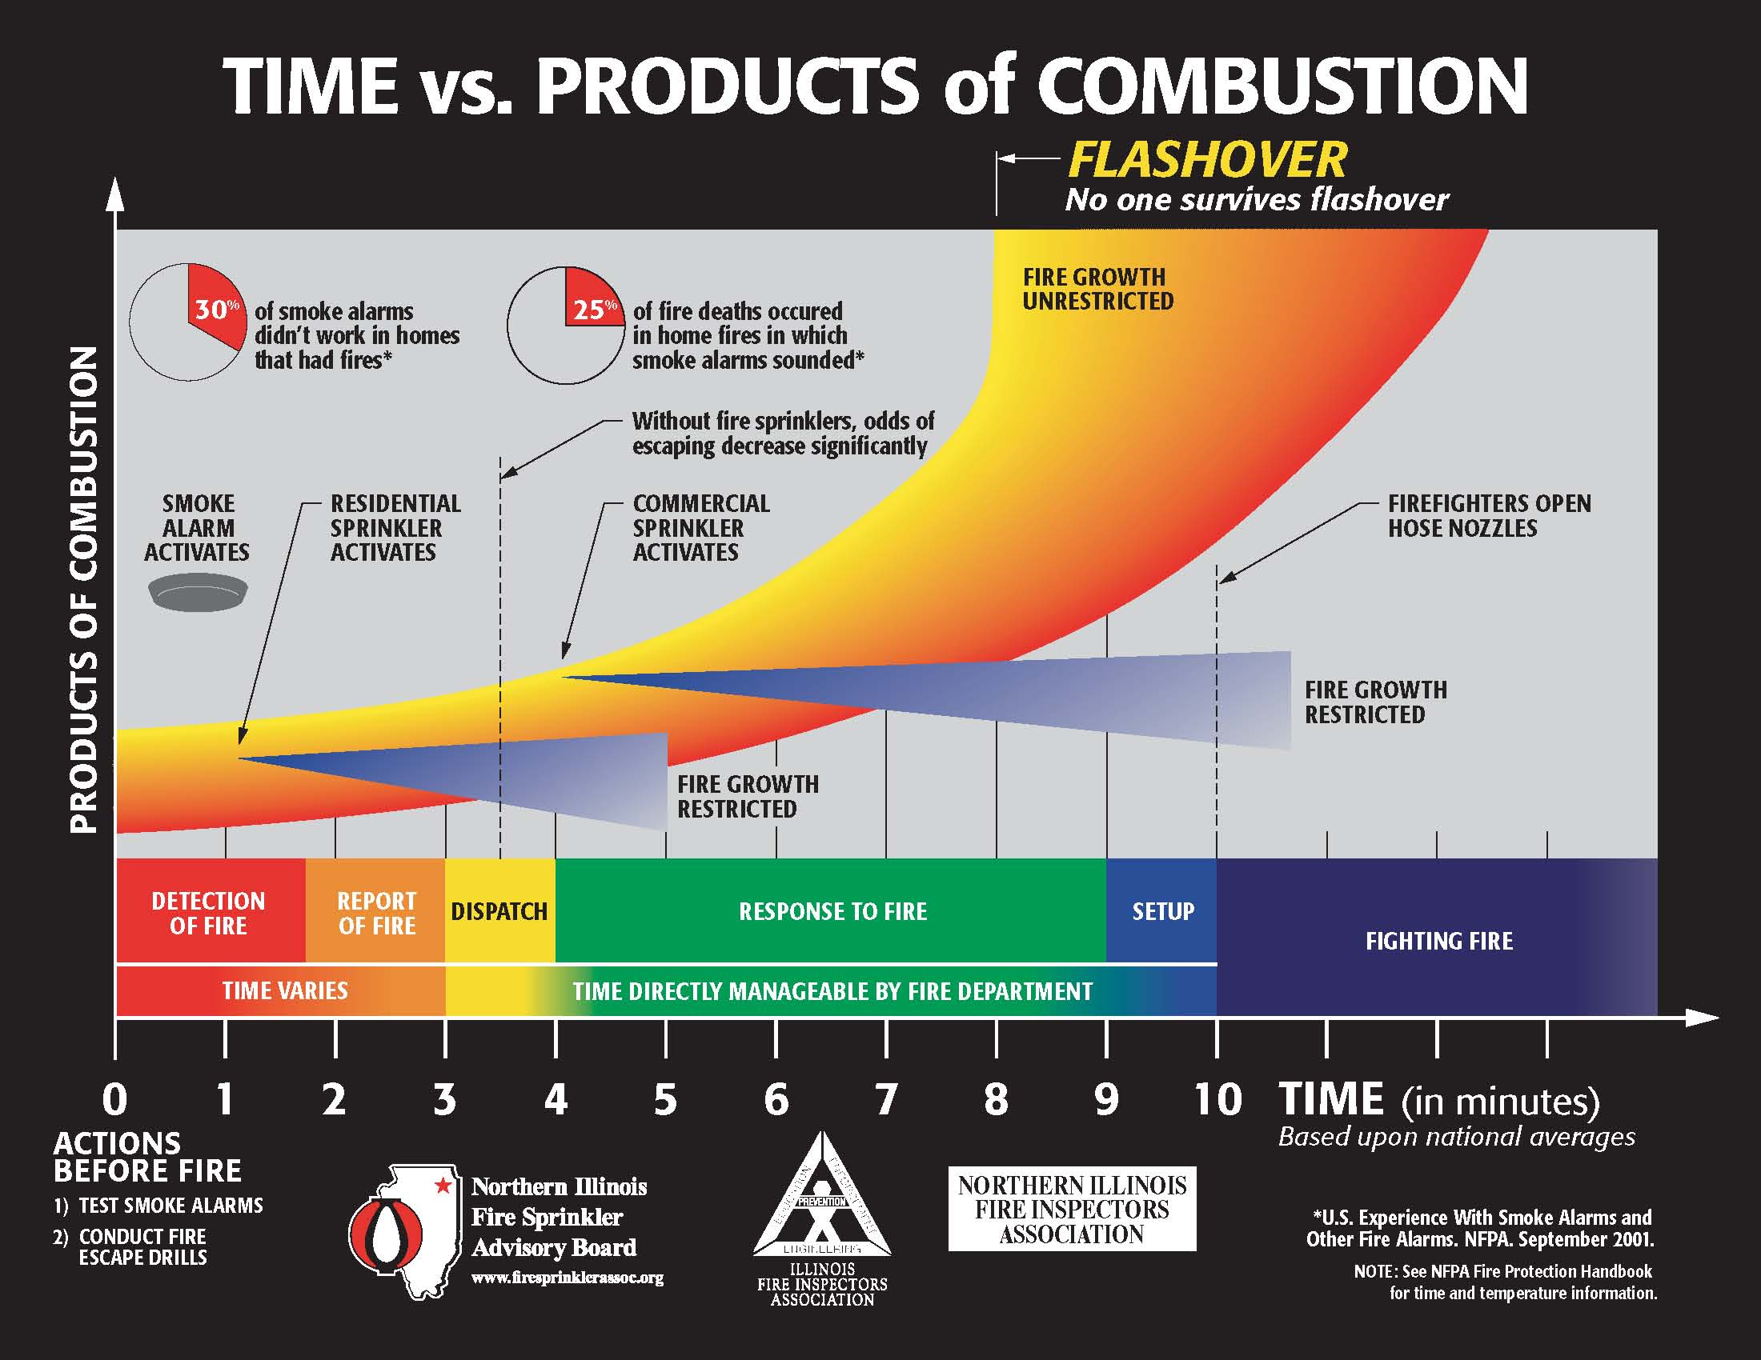
    - “The arrival of first responders with automatic external defibrillator capability before the onset of brain death, and the arrival of adequate fire suppression resources before flash-over is a critical event during the mitigation of an emergency, and is in the public's best interest.”

Figure 2 Time verse Products of Combustion & Restriction of Fire Growth by Automatic Fire Sprinklers
Sprinkler systems in residential properties support Washington’s Growth Management Act (GMA):
  - RCW 36.70A.020 (12) Public facilities and services. Ensure that those public facilities and services necessary to support development shall be adequate to serve the development at the time the development is available for occupancy and use without decreasing current service levels below locally established minimum standards.
- Sprinkler systems in residential properties support Washington’s State Environmental Policy Act (SEPA)
  - RCW 43.21C.020 (1) The legislature, recognizing that man depends on his biological and physical surroundings for food, shelter, and other needs, and for cultural enrichment as well; and recognizing further the profound impact of man's activity on the interrelations of all components of the natural environment, particularly the profound influences of population growth, high-density urbanization, industrial expansion, resource utilization and exploitation, and new and expanding technological advances and recognizing further the critical importance of restoring and maintaining environmental quality to the overall welfare and development of man, declares that it is the continuing policy of the state of Washington, in cooperation with federal and local governments, and other concerned public and private organizations, to use all practicable means and measures, including financial and technical assistance, in a manner calculated to: (a) Foster and promote the general welfare;
- Sprinkler systems in residential properties support Washington’s Subdivision Code.
  - RCW 58.17.110 (2) A proposed subdivision and dedication shall not be approved unless the city, town, or county legislative body makes written findings that: (a) Appropriate provisions are made for the public health, safety, and general welfare…

Closing Statement
The inclusion of a requirement for automatic sprinkler systems in residential structures is the safest and most cost effective method to immediately reduce risk to the public. Failure to reduce risk has a direct impact upon costs—to building occupants, to the fire service community and to the taxpaying public who is ultimately responsible for funding the fire service to an adequate level of service. Reducing risk will help stop the continued level of fire service erosion happening across the State of Washington. Please support passages of the 2006 International Residential Code as submitted by the International Code Council and reject the amendments offered by the Washington Building Industry.

U.S. Census Bureau, Population Division, Interim State Population Projections, 2005. Internet Release Date: April 21, 2005
From Pg 4 of the USFA Assessment;
Washington; Four Years Later, Table 3
National Institute of Standards and Technology report #7451, pg ES1

